Year 5 Learning
Topic | The Art of Anatomy | Art and Fashion | A Study of Surrealism
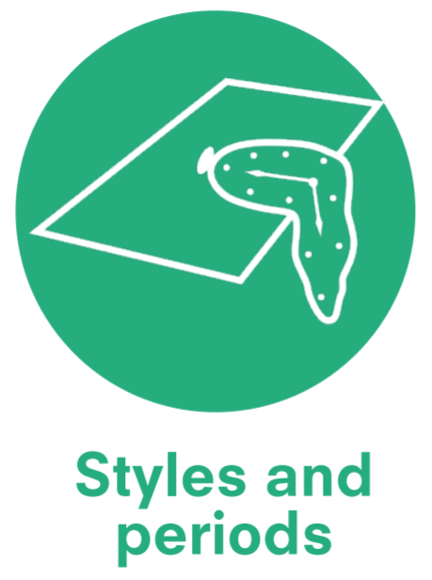 | Renaissance Art  (1400–1600) | Op (optical) art  1960s | Surrealism  (1916–1950)
 | Phidias (c. 480-430 BCE) Ancient Greek Sculptor and painter  Myron of Eleutherae (c.480-440 BCE) Ancient Greek Sculptor  Leonardo Da Vinci (1452-1528) German Painter and printmaker  Albrecht Durer (1471-1528) German painter and printmaker  Andreas Vesalius (1514-64) Belgian anatomist and physician  Sokari Douglas Camp (Born 1958) Black British Sculptor | Édouard Manet (1832-83) French Modernist painter  Piet Mondrian (1872-1944) Dutch Abstract artist  Pablo Picasso (1881-1973) Spanish painter and sculptor  Victor Vasarely (1906-97) Hungarian Op artist Richard Serra (born 1938) American printer and sculptor | Paul Klee (1879-1940) Swiss Painter  Max Ernst (1891-1976) German Painter and Sculptor  Joan Miro (1893-1983) Spanish Painter and Sculptor  Rene Magritte (1898-1967) Belgian Painter  Alberto Giacometti (1901-66) French Sculpture  Salvador Dali (1904-89) Spanish Painter  Ronald Moody (1900-84) Jamaican Sculptor  Antoni Gaudi (1852 -1926)  Spanish Artist
Knowledge Categories |   Techniques |   Visual Language | Visual Language
Knowledge Categories |   Process |   Media and materials |   Colour theory
Knowledge Categories | Visual Language | Colour theory |   Effects
Knowledge Categories | Media and materials | Process |   Emotions
Knowledge Categories | 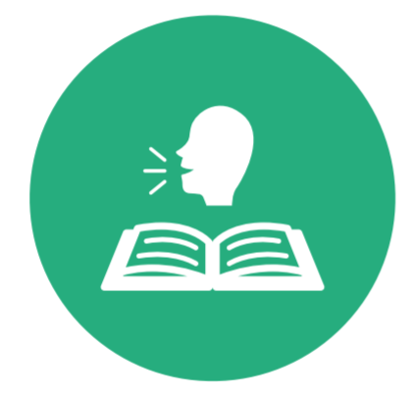  Vocabulary | Effects | Process
Knowledge Categories |  | Vocabulary | Techniques
Knowledge Categories |  |  | Vocabulary

Master practical skills
Techniques | Media and materials | Colour theory
Media and materials | Colour theory | Effects
 | Effects | Techniques
Drawing  - Use a choice of techniques to depict movement, perspective, shadows and reflection.  - Choose style of drawing suitable for the work (e.g. realistic or impressionistic). | Drawing  - Develop a personal study of painting, drawing, based on ideas from other artists.  - Use a variety of techniques to add interesting effects. | Paint  - Create a colour palette based upon colours observed in the natural or built world.  - Develop a personal study of painting, drawing, based on ideas from other artists.
Sculpture  - Use tools to carve and add shapes, texture and pattern. |  | Collage  - Select and arrange materials for a striking effect.  - Ensure work is precise.  - Mix textures (rough and smooth, plain and patterned).  - Combine visual and tactile qualities.
Print
- Create an accurate pattern, showing fine detail.

Potential opportunities for cultural capitalism
 | Visit to the Victoria & Albert museum – also links to history | Display work for parent/carers in whole school gallery.

Year 6 Learning
Topic | The explosion of Pop Art | Exploring Expressionism | Cultural Tradition in Art
 | Pop Art  (1950s–1960s) | Futurism | Folk Art
 | Roy Lichtenstein (1923-97) American Painter  Eduardo Paolozzi (1924-2005) British Sculptor and Painter  Andy Warhol (1928-87) American Artist  Jasper Johns (born 1930) American Painter, Sculptor and Printmaker  David Hockney (born 1937) British Painter, print maker and photographer | Umberto Boccioni | Richard Kimbo (contemporary)
Knowledge Categories | Techniques | Visual Language | Visual Language
Knowledge Categories | Process | Colour theory |   Emotions
Knowledge Categories | Visual Language | Techniques | Process
Knowledge Categories | Effects | Process | Media and materials
Knowledge Categories | Emotions | Vocabulary | Vocabulary
Knowledge Categories | Colour Theory |  | Effects
Knowledge Categories | Vocabulary

Master practical skills
Effects | Colour theory | Media and materials
  Techniques | Techniques | Effects
Colour theory
Paint  - Create a colour palette based upon colours observed in the natural or built world. | Paint  - Create a colour palette based upon colours observed in the natural or built world. | Paint  - Combine colours to enhance mood of piece.
Drawing  - Choose style of drawing suitable for the work (e.g. realistic or impressionistic). | Collage  - Mix textures (rough and smooth, plain and patterned).  - Combine visual and tactile qualities. | Sculpture  - Show lifelike qualities and real-life proportions or, if more abstract, provoke different interpretations.  - Use tools to carve and add shapes, texture and pattern.
Print  - Build up layers of colours  - Use a range of visual elements to reflect the purpose of the work.  - Create an accurate pattern, showing fine detail. |  | Collage  - Mix textures (rough and smooth, plain and patterned).  - Combine visual and tactile qualities.
Potential opportunities for cultural capitalism
Andy Warhol virtual exhibition at Tate Modern: Andy Warhol | Tate | Matisse in French lessons. | Display work for parent/carers in whole school gallery.

