Year 3 Learning
Topic | Animals | All work and no play | Abstract Art
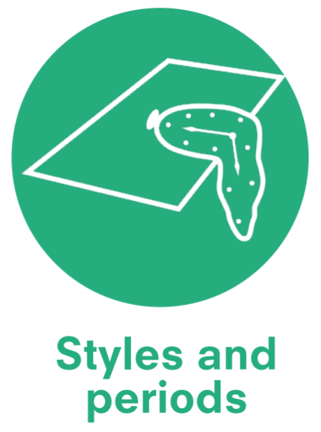 | Medieval Art |  | Abstract Art  (Modern form)
 | Albrecht Durer (1571-1528)  German Painter and Printmaker  George Stubbs (1724-1806)  British Painter  Rosa Bonheur (1822-99)  French Painter and Sculptor  Franz Marc (1880-1916)  German Painter and Printmaker  Damien Hirst (born 1965)  British Artist  Chris Ofili (born 1968)  Black British Artist  Joseph Thiongo (born 1967)  Kenyan Artist | Pieter Brueghel (1525-69) Dutch Painter  Gabriel Metsu (1629-97) Dutch Painter  Joseph Wright (1734-97)  English Painter  L.S. Lowry (1887-1976) English Painter  Lubaina Himid (1954 – Present) British Artist | Wassily Kandinsky (1866-1944)  Russian Painter  Piet Mondrian (1872-1944)  Dutch Painter  Henry Moore (1898-1986)  English artist and sculpture  Sonia Delaunay (1885-1979)  French Painter  Mark Rothko (1903-70)  American Painter  Jackson Pollock (1912-46)  American Painter  Alma Woodsey Thomas (1891-1978)  African Painter  Frank Bowling (1936 -)  Black British Artist  Norman Lewis (1909 – 1979)  African American Artist
Knowledge Categories |   Media and materials |   Visual Language |   Colour theory
Knowledge Categories |   Techniques |   Emotions | Techniques
Knowledge Categories |   Effects |   Process | Media and materials
Knowledge Categories | Visual Language | Colour theory | Process
Knowledge Categories | Process | Effects | Emotions
Knowledge Categories | 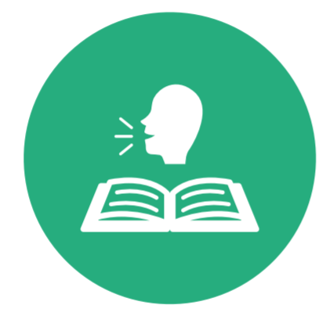  Vocabulary | Techniques | Visual Language
Knowledge Categories |  | Vocabulary | Vocabulary
Master practical skills
Effects |   Techniques | Media and materials
Media and materials |   Colour theory | Techniques
Techniques | Effects | Colour theory
Drawing  - Use different hardnesses of pencils to show line, tone and texture.  - Sketch lightly (no need to use a rubber to correct mistake). | Drawing  - Sketch using pencil or charcoal. | Paint  - Experiment with line, shape and colour to create abstract art.
Paint  - Use a number of brush techniques.  - Use thick and thin brushes to produce shapes, textures, patterns and lines.  - Use watercolour paint to produce washes for background then add detail. | Paint  - Mix colours effectively.  - Experiment with creating mood.  - Create tones using different tools.
Collage
- Use overlapping.
- Mix materials to create texture.

Potential opportunities for cultural capitalism
 | Useful websites:  L.S Lowry Exhibition | The Lowry  LS Lowry's Work | About LS Lowry | The Lowry | Display work for parent/carers in whole school gallery.

Year 4 Learning
Topic | Impressionism | A Journey into Space | Myths and legends
 | Impressionism  19th century |  | Pre-Raphaelite painting  19th century
 | Alfred Sisley (1839 – 99) British artist  Pierre-Auguste Renoir (1841 – 1919) French painter | Lucien Rudaux (1874-1947) French Artist  Chesley Bonestell (1888-1986) American Artist  David A. Hardy (born 1936) British Artist  Robert McCall (1919-2010) American Artist | Alessandro Botticelli (1445-1510)  Italian painter  Peter Paul Rubens (1577-1640) Flemish artist  George Frederic Watts (1817-1904)  British painter and sculptor  Dante Gabriel Rossetti (1828-82)  British poet and painter  Edward Burne-Jones (1833-98) British artist and designer  Joan Jonas (born 1936) American sculptor and visual artist
Knowledge Categories | Media and materials | Visual Language | Process
Knowledge Categories | Techniques | Emotions | Techniques
Knowledge Categories | Effects | Process | Media and materials
Knowledge Categories | Visual Language | Colour theory | Colour theory
Knowledge Categories | Colour theory | Vocabulary | Effects
Knowledge Categories | Emotions |  | Vocabulary
Knowledge Categories | Vocabulary

Master practical skills
Effects | Colour theory |  | Media and materials
Media and materials |  |  | Techniques
Techniques |  |  | Effects
Colour theory |  |  | Colour theory
Drawing  - Use hatching and cross hatching to show tone and texture. | Sculpture  - Create and combine shapes to create recognisable forms (e.g. shapes made from nets or solid materials) (DT – tea cups from clay) | Drawing  - Annotate sketches to explain and elaborate ideas.
Paint  - Use a number of brush techniques using thick and thin brushes to produce shapes, textures, patterns and lines.  - Experiment with creating mood. | Paint  - Use a number of brush techniques using thick and thin brushes to produce shapes, textures, patterns and lines.  - Mix colours effectively.  - Experiment with creating mood | Collage  - Select and arrange materials for a striking effect.  - Ensure work is precise.  - Use overlapping.
Potential opportunities for cultural capitalism
Display work for parent/carers in whole school gallery.
Visit to space centre.

