KS1

Year 1 Learning |  |  | Year 2 Learning
Portable Snacks  CQ ref pg. 133-147 | Picture Perfect  CQ ref pg. 79-98 | Bookmarks (sewing) | Teddy’s Beachmat (sewing) | Couscous Dish  CQ ref pg.149-160 | Wind-powered Wheels  CQ ref pg. 115-131
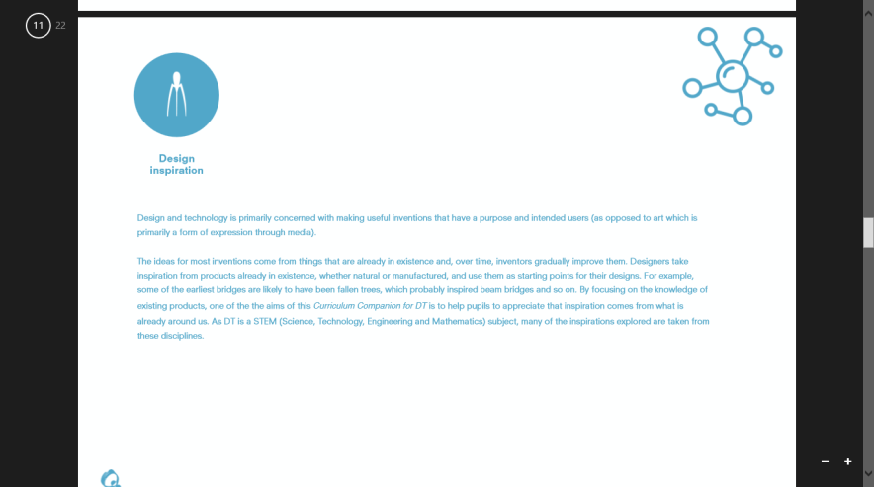  Design Inspiration | 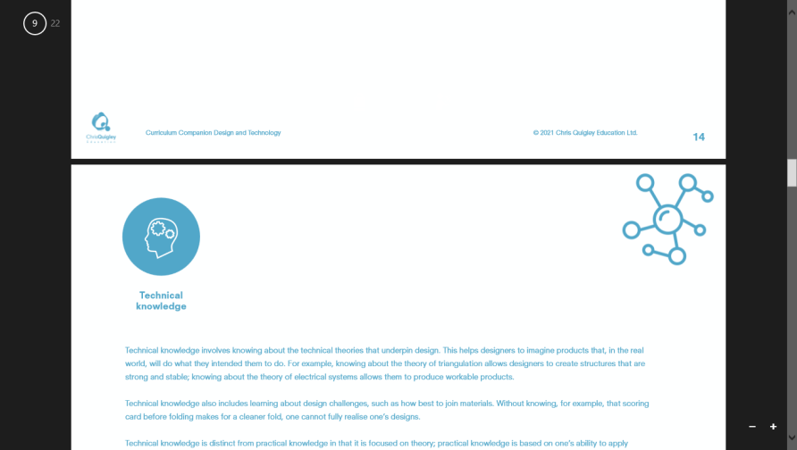  Technical Knowledge | Technical Knowledge | Technical Knowledge | Technical Knowledge | Technical Knowledge
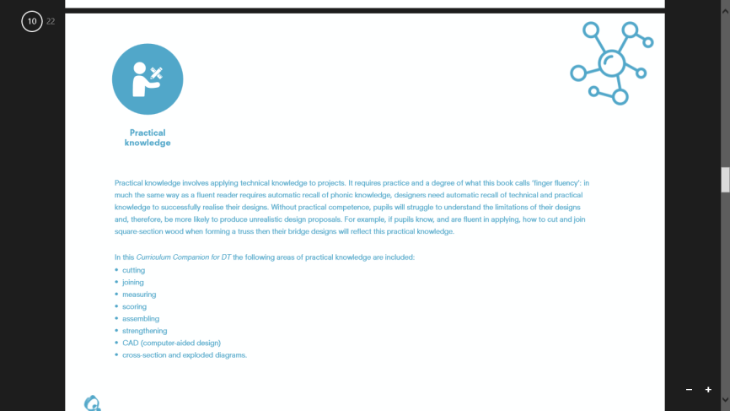  Practical Knowledge | Practical Knowledge | Practical Knowledge | Practical Knowledge | Practical Knowledge | Practical Knowledge
Design Process  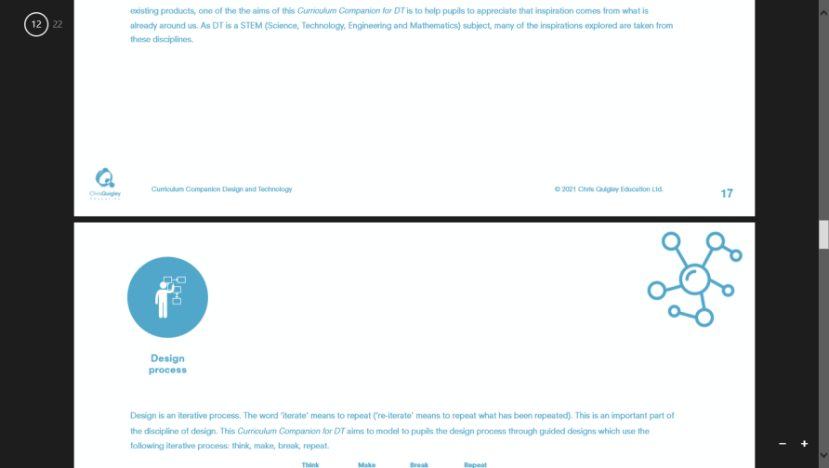 | Design Inspiration | Design Inspiration | Design Inspiration | Design Inspiration | Design Inspiration
Vocabulary  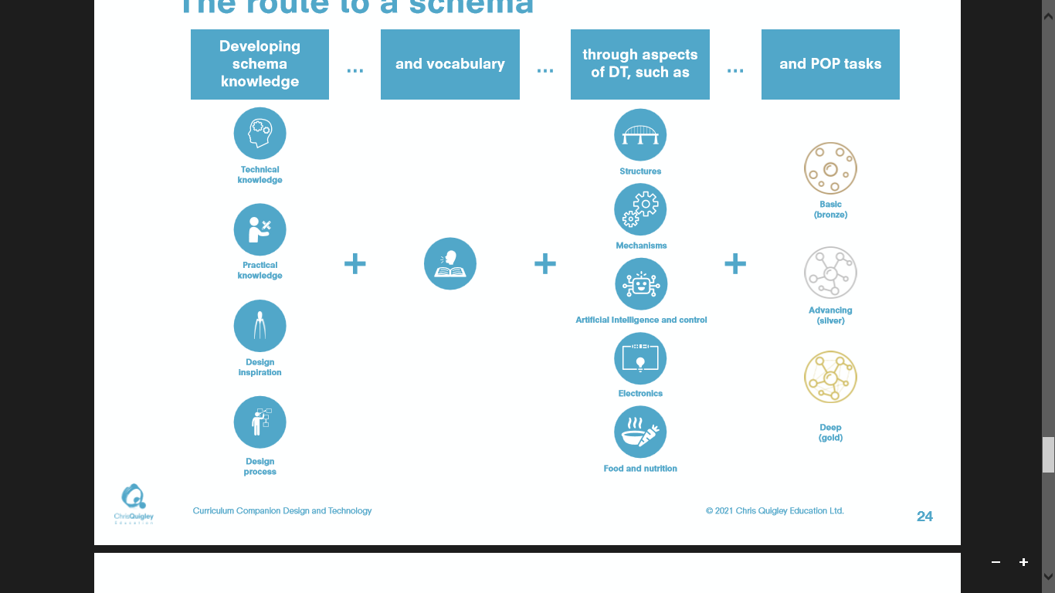 | Design Process | Design Process | Design Process | Design Process | Design Process
 | Vocabulary | Vocabulary | Vocabulary |  | Vocabulary
Key Person: |  |  | Key Person:
Jamie Oliver |  |  | Mourad Lahou | Orla Kiely | Elon Musk (Tesla)
Making links with: |  |  | Making links with:
 |  |  | Portable Snack from Y1 | Beautiful Bunting from Y1 | Picture Perfect from Y1
Top Tips: | Top Tips: | Top Tips: | Top Tips: | Top Tips: | Top Tips:
Determine the selection of ingredients which the children can select from. Include an experience activity of tasting. | Provide each child with a zippy wallet or similar to put all of their materials into. | Use binka with a knotted thread. Differentiate with needle – aim for all children to use a small eyed metal needle, but allow them to practise on plastic needles if necessary. | Determine the selection of ingredients which the children can select from. Include an experience activity of tasting.  Cohort 2021-2022 arranged for the kitchen to prepare the cous cous, and the children simply added their ingredients to it. | Use small eyed metal needles, and teach to overstitch to secure (not knots).  Try to plan in a range of materials for them to explore e.g. cotton, hessian, wool. | Collect packaging and recycling ahead of beginning this. Suggest they only bring in what they need – use thicker art straws for axels and bottle tops so children can take them home.

Lower KS2

Year 3 Learning |  |  | Year 4 Learning
Delicious Dips  CQ ref pg. 293-304 | Coin Collecting | We’ll Cross that Bridge  CQ ref pg. 243-258 | Vegetable Soup  CQ ref pg.149-160 | Pneumatics  CQ ref pg 225-241 | A Chair for a Bear  CQ ref pg. 261-278
Design Inspiration | Technical Knowledge | Technical Knowledge | Design Inspiration | Technical Knowledge | Technical Knowledge
Design Process | Practical Knowledge | Practical Knowledge | Practical Knowledge | Practical Knowledge | Practical Knowledge
Vocabulary | Design Inspiration | Design Inspiration | Design Process | Design Inspiration | Design Inspiration
 | Design Process | Design Process | Vocabulary | Design Process | Design Process
 | Vocabulary | Vocabulary |  | Vocabulary | Vocabulary
Key Person: |  |  | Key Person:
 | Mary Quant | Isambard Kingdom Brunel |  | Holt & Best
Making links with: |  |  | Making links with:
Portable Snack Y1 | Sewing Y1&Y2 | Wind-powered Wheels Y2 | Couscous Dish Y2 | Wind-powered Wheels Y2  We’ll Cross that Bridge Y3 | We’ll Cross That Bridge Y3
Top Tips: | Top Tips: | Top Tips: | Top Tips: | Top Tips: | Top Tips:
Determine the selection of ingredients which the children can select from. Include an experience activity of tasting.  Cooking equipment will be required. |  | 2021-2022 cohort used different sized lollypop sticks instead of wood to good effect. | Determine the selection of ingredients which the children can select from. Include an experience activity of tasting. You will need to plan for cooking facilities.  Slow cookers needed. | 2021-2022 cohort used takeaway polystyrene boxes and glue guns, powered with syringes and tubes.  Show children how pneumatics are used in construction/robots etc. | This unit needs lots of corrugated card – start collecting empty boxes early!

Upper KS2

Year 5 Learning |  |  |  |  | Year 6 Learning
Brilliant Bread  CQ ref pg. 427-442 |  | Reusable Tote Bag | Building the Future  CQ ref pg. 353-368 |  | Beautiful Bolognese  CQ ref pg. 441-452 |  | Cams  CQ ref pg. 403-418
Design Inspiration |  | Technical Knowledge | Technical Knowledge |  | Design Inspiration |  | Technical Knowledge
Practical Knowledge |  | Practical Knowledge | Practical Knowledge |  | Design Process |  | Practical Knowledge
Design Process |  | Design Inspiration | Design Inspiration |  | Vocabulary |  | Design Inspiration
Vocabulary |  | Design Process | Design Process |  |  |  | Design Process
 |  | Vocabulary | Vocabulary |  |  |  | Vocabulary
Key Person |  |  |  |  | Key Person:
Paul Hollywood |  |  |  | Norman Foster | Antonio Carluccio
Making links with: |  |  |  |  | Making links with:
Couscous Dish Y2  Dips Y3 |  | We’ll Cross that Bridge Y3 | We’ll Cross that Bridge Y3 |  | Vegetable Soup Y4 |  | We’ll Cross that Bridge Y3
Top Tips: |  | Top Tips: | Top Tips: |  | Top Tips: |  | Top Tips: | Top Tips:
Determine the selection of ingredients which the children can select from. Include an experience activity of tasting. You will need to plan for cooking facilities. |  | You will need lots of Art Straws and string for this, along with some lightweight material.  Consider which term you do this in – will it be windy!? | Collect packaging and recycling ahead of beginning this. This way the children can plan in using specific items. – cups, boxes and toilet/tissue tubes. |  | Determine the selection of ingredients which the children can select from. Include an experience activity of tasting. You will need to plan for cooking facilities.  Slow cookers needed. |  | 2021-2022 Cohort had some material difficulties – next year try boxes, with the holes reinforced with a metal/wooden washer.

