Croyland Primary School-Geography Long Term Plan: KS1

Year 1 Learning |  |  | Year 2 Learning
Weather across the UK | Countries and Capitals of the UK | The World | UK and Ghana comparison | Continents and Oceans | Climate
Curriculum maps used

Weather Extreme Weather | The UK: England  The UK: Scotland  The UK: Wales  The UK: N. Ireland  England: London  Scotland: Edinburgh  Wales: Cardiff  N. Ireland: Belfast | Mapping the World 1  Mapping the World 2 | Ghana  Ghana:Sunyani | Continents and Oceans  The Arctic Ocean  The Atlantic Ocean  The Pacific Ocean  The Indian Ocean  The Southern Ocean | Climate
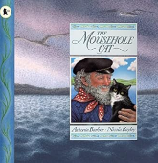  The Mousehole cat - Antonia Barber | 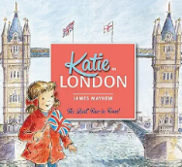  Katie in London -  James Mayhew  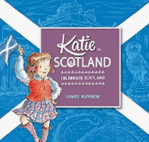  Kate in Scotland - James Mayhew  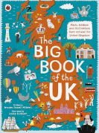  The big book of the UK -  Imogen Russel williams  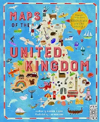  Maps of the United Kingdom - Rachel Dixon | 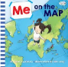  Me on the Map - Joan Sweeny  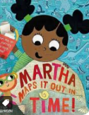  Martha Maps it Out  Leigh Hodginkson | 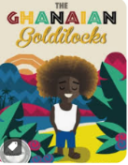  Ghanaian Goldilocks -  Tamara Pizzoli | 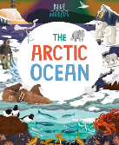  The Arctic Ocean -  Anita Ganeri  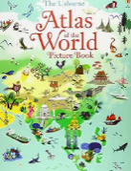  Atlas of the World Picture - Sam Lake | 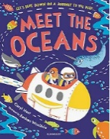  Meet the Oceans – Caryl Hart
Knowledge Categories |  |  | Knowledge Categories
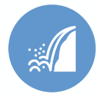  Physical Processes | 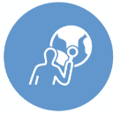  Location |   Techniques | Location | Location | Location
Techniques | 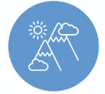  Physical Features | 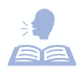  Vocabulary | Physical Features | Physical Features | Physical Features
Vocabulary |   Human Features |  | Human Features | Human Features | Vocabulary
 |   Diversity |  | 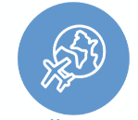  Human Processes | Diversity
 | Human Processes |  | Vocabulary | Human Processes
 | Vocabulary |  |  | Vocabulary
Making links with: |  |  | Making links with:
Countries and Capitals of the UK (Y1)  Climate (Y2) | Mapping the world (Y1)  Continents and Oceans (Y2) |  | Climate (Y2)  Countries and Capitals of the UK (Y1) | Mapping the world (Y1)  Countries of the UK (Y1) | Weather across the UK (Y1)  Climate change (Y5)
Top Tips: | Top Tips: | Top Tips: | Top Tips: | Top Tips: | Top Tips:
Use PHILIPS KS1 (new) atlases to find the following:  Pg 8-9 understanding maps  Have a weather chart in class throughout the topic or year and have a weather monitor to change the weather each day using pictures and vocab. Discuss in lessons, pictures and vocab that has been use throughout the week | Use PHILIPS KS2 (new) atlases to find the following:  Pg 24-27 UK  - Show countries and capitals in different ways, maps, globes, atlases  - Use maps around the school, these show the world in different ways  - Use photos of human and physical features  May be a longer topic | Use PHILIPS KS2 (new) atlases to find the following:  Pg 8-9 Weather and climate | PHILIPS KS1 (new) atlases to find the following: | Use PHILIPS KS1 (new) atlases to find the following:  Pg 10-11 Oceans. Continents and countries  - Show continents and oceans in different ways, maps, globes, atlases  - Use maps around the school, these show the world in different ways  - Use photos of human and physical features  May be a longer topicUse | Use PHILLIPS KS2 (new) atlases to show children information on Climate.  Pg 8-9 climate of the UK  Pg 32-33 Climate  Use WAYLAND (old) atlases  Pg 10-11 Climate zones  Pg 34 British Isles Climate  Use COLLINS atlases (older)  Pg 24 Uk Climate  Pg 62-63 World Climate
Fieldwork Suggestions |  |  | Fieldwork Suggestions
- Take opportunities where possible to get outside on days where the weather is different to discuss back in class in lessons |  | Fieldwork suggestions: school grounds walk  - Children to take photos in and around the school of human and physical features  - Create a simple map identifying 3 physical features (field, hedgerows in science garden, hilly area of millennium garden)  - Use compass points to give directions from each feature on their map | Fieldwork suggestions: Wellingborough locality  - Children to visit local places of interest and human features  - Take photos and use photos already given  - Previous to visit, children to answer questionnaires in class about what they need to know and find out  - Make sketches and notes about places of interest in Wellingborough  Use back in class to compare to Ghana
Diversity | Diversity | Diversity | Diversity | Diversity | Diversity
 | Ensure that it is made clear that other places in the world are built up of a number of countries e.g. 4 countries make up UK, States make up America, provinces make up Pakistan. | -Show children a range of maps the Mercator projection map (standard map you see) size countries have been enhance but not others.  -Show children peters projection map to see the real sizes and scale of countries.  - encourage children to discuss where they are from and share knowledge of that culture. |  | -Show children a range of maps the Mercator projection map (standard map you see) size countries have been enhance but not others.  -Show children peters projection map to see the real sizes and scale of countries.
Developing Cultural Capital |  |  | Developing Cultural Capital
Discuss: If it is raining in Wellingborough it might not be in other parts of the UK. Show weather charts across UK linking back to countries and capitals | Discuss: Discuss the famous landmarks in each of the capital cities of the UK. Could you identify the city - the landmark?  POP Task: Know that Wellingborough is a town and compare it to the capital cities of the UK. Discuss size in a way Year 1s will understand. | . POP Task: Show Wellingborough on a zoomed in map and a map of further away. What is the same and what is different? | Discuss: talk about the key landmarks of Ghana and compare them to that of the UK.  POP Task: Compare everyday life for a school child in Ghana to a child in England. | POP Task: To know the terms city, country, continent and children should be able to describe where they are in relation to those key words. | Discuss: If it is raining in Wellingborough it might not be in other parts of the UK.  POP Task: Discuss the physical features of Wellingborough and a different place. Give reasons for what the climate might be in that particular place and why.
RESOURCES

Year 1

The World:
- Atlases
- Globe
- Map
- (Compass directions) https://www.youtube.com/watch?v=f2I81_BFb-s
- (hemispheres and equator) https://www.youtube.com/watch?v=_pOKoIAnybg

Countries and Capitals of the UK:
- (countries and capitals of UK) https://www.youtube.com/watch?v=ncqDJW4EhmE
- (UK capitals) https://www.youtube.com/watch?v=rzEG-_uWA8

Weather across the UK:
- https://www.twinkl.co.uk/resource/tp-g-027-planit-geography-year-1-wonderful-weather-unit-pack

Year 2

Continents and Oceans:
- Atlases
- Globe
- Map
- (continents and oceans) https://www.youtube.com/watch?v=dk8zDjQT0aE
- (hemispheres and equator) https://www.youtube.com/watch?v=_pOKoIAnybg

UK and Ghana comparison:

Climate:
- (climate vs weather) https://www.youtube.com/watch?v=YbAWny7FV3w
- (weather around the world, live) https://www.timeanddate.com/weather/

