Progression of Knowledge
 | Healthy lifestyles- | Everyone belongs (diversity) | Road Safety | Hygiene, hands and teeth | S.R.E | Water/sun safety | Fire Safety | Litter/  recycling | Drug education | Taking Responsibility | Playing an active role as citizens- | Sustainable development/ Food for life | First Aid | Citizenship | Money Sense | Knife crime/ anti social behaviour
R | *Manage own needs  *Healthy lifestyles | *similarities of us and our friends  Panda and penguin find a thing - Zehra Hicks  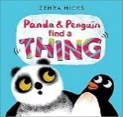  Meesha makes friends - Tom Percival  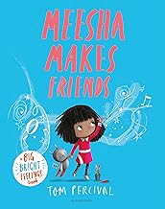 |  | *Healthy lifestyles  *Managing self |  | *Keeping safe in the sun
1 | *healthy eating  *physical activity  *benefits of regular exercise  *Food likes and dislikes  *balanced meal  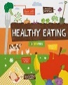  Healthy eating - Harriet Brundle | *understand physical, verbal and cyber bullying  * How it feels  * Who to talk to  *How to help someone  *What to do if they see it happening.  Teasing isn’t fun - Melissa Higgins  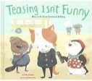  Old Macdonald had a phone - Jean Willis  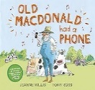  Kind - Alison Green  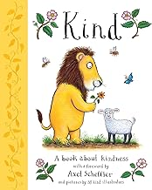 | *staying safe crossing the road  *be bright, be seen,  *holding hands  *car safety laws | *protect and clean teeth  *healthy lifestyle  *washing hands-practical  *stopping the spread of germs and disease  My wobbly tooth - Lauren child  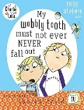 | *human babies change as they grow  *naming emotions  *similarities between people  *families can be different but all special  * underwear rule  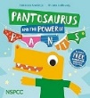  How do I grow? - Madeline Tyler  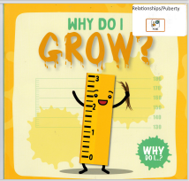  Find your happy - Emily Coxhead  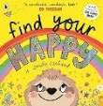  The Hueys in the new jumper - Oliver Jeffers  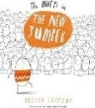 | *dangers associated with water and the beach  *staying safe near water  *protection from the sun
2 | *food is a basic requirement for life  *Eatwell plate and 5 food groups  *planning a meal using the food groups  Healthy eating - Gemma McMullen  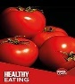 | *Identify difficult feelings  *Develop empathy  *Recognise their own feelings and worth  *Exclusion through bullying  ‘The Invisible’ - Tom Percival 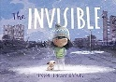  The red beast - K.I.Al-Ghani  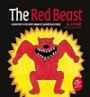  Unplugged - Steve Anthony  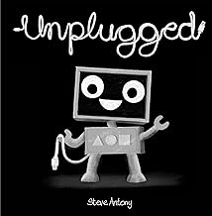  Finn’s little fibs - Tom Percival  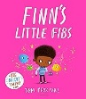  This is me - George Webster  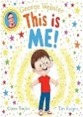  My beautiful voice - Joseph Coelho  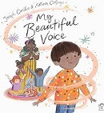 |  |  | *different types of families  *recognising their home life  *love, care, feelings  *leaving, loneliness  * underwear rule  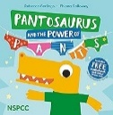  And tango makes three - Justin Richardson  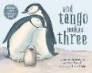  How do I feel about My stepfather - Julie Johnson  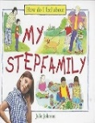  The same but different - Molly Potter  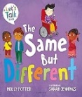 |  | *identify fire hazards  *causing a fire  *fire safety  *fire plan  Mog’s Christmas calamity - Judith Kerr  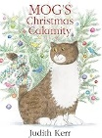 | *recycling and how to do it  *effects of littering on the environment  *how can you change the environment  The odd fish - Naomi Jones  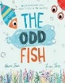 | *actions have consequences  *safe use and storage of medicines  *difference between medicine and sweets  Talking about drugs - Sarah Levete  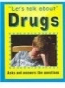 |  |  |  | identify dangers  *how to call 999  How do I bleed? By Kirsty Holmes  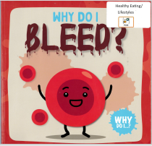  The children’s book of first aid skills  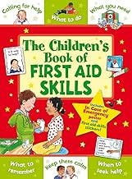
3 | *food and diets around the world  *healthy /balanced diet  *food substances that provide nutrients, water and fibre  Food and digestion - Andrew Solway  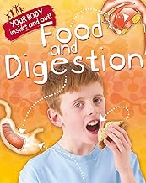 | *Safe use of internet and mobile phones  *Consequences of misuse  *Reporting of bullying  *Long term effects  *Human rights are the basic standard  *Everyone has these rights  Chicken Licking by Jean Willis  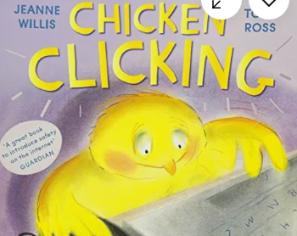  The lion who learned - Frances Stickley  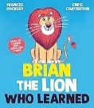 | *safe and unsafe behaviours  *consequences  *road signs  *types of crossings |  | *understanding death and loss  *how changes can make them feel  *belonging to groups  *understanding feelings and actions(wellbeing)  Rory’s room of rectangles - Ian Eagleton  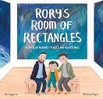  The invisible string - Patrice Karst  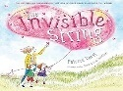  The invisible leash - Patrice Karst  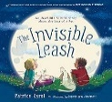  Can anyone be as gloomy as me? - Nick Toczek  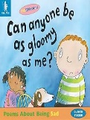  Roots of Love - Sarah Asuquo  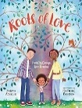  The Koala who could - Rachel Bright  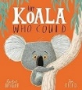 |  |  |  |  | *all humans have needs  *RSPCA  *what pets need  *Guide dogs | *make connections between their learning and the world of work  *differences and similarities between people  *learn about the jobs others have  *develop skills to make their own contribution |  |  |  |  | *carrying knives/ consequence
4 | *food and diets around the world  *healthy/ balanced diet  *benefits of exercise  *healthy eating can affect mental health  *healthy lifestyles  *exercise effects physical and emotional health  Health and fitness - Gemma McMullen  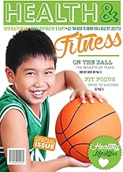 | *Consequences of misusing the internet  *Accepting diversity  *Impact on victim  *rich and poor  *UNCRC- all children should have the same rights  Leo the octopus - Isabelle Marinov  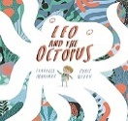  The pop up gremlins - Twinkl  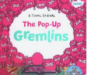  Smeds and smoos - Julia Donaldson  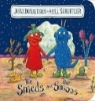 |  | Hygiene routines as part of S.R.E. | *changes in nature  *naming body parts  *changes that happen in puberty  *changes from child to adult  *hygiene routines  *wellbeing  Ruby’s worry - Tom Percival  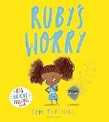 | *hidden dangers near water  * Discuss SAFE message  Stay Away From the Edge.  *assess hazards and risks for themselves | *how fires start  *causes/ prevention  *smoke alarms  *fire plans | *allocation of resources  *effects of economic choices  *environmental effects  *media  * decisions on waste and recycling  Small steps, big change - Annmarie Cool  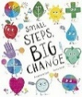 | *understanding of the word drug  *dangerous if not used properly  *safety/rules  *pressure/persuasion  *smoking  *personal health targets  Talking about drugs - Sarah Levete  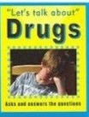
5 |  | *cyberbullying and its consequences  *Injustice and senselessness of racism  *Prejudices due to misinformation and generalisations  *equality and diversity  Wild - Annette Demetriou  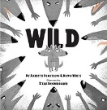  #Goldilocks - Jean Willis  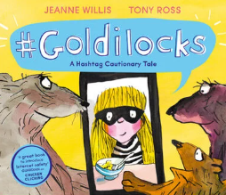  Racism - Harriet Brundle  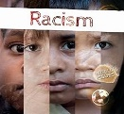  The bear and the piano by David Lichfield  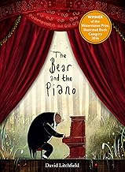 | Bikeabilty | Hygiene routines as part of S.R.E | *embarrassing situations  *bodily and emotional changes at puberty  *periods  *wet dreams  *emotional health and well being  *types of relationships  *wellbeing  Puberty and growing up - John Wood  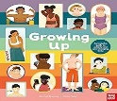  Own your period - Chella Quint  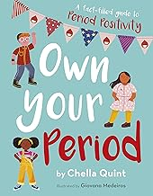 |  |  |  |  |  |  | *definition of sustainable development  *environmental issues  *solutions  *global trade in food  *environment-al costs of transportation | *identify dangers  *how to call 999  *what information to give  *what to do in an emergency  *practical first aid course  The children’s book of first aid skills |  | * Weekly budgeting *Income and expenditure *Understand loans  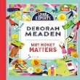  Why money matters - Deborah Meaden | *what is anti -social behaviour  *laws  *vandalism  *effects on community  *littering  *graffiti  *budgetary limitations  *carrying knives/ consequence  A planet full of plastic - Neal Layton  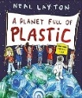  Clean up - Nathan Byron  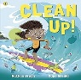
6 | *discuss healthy eating  * ways to eat more healthily  *effects of smoking  *alcohol and the media’s influence  *all medicines are drugs but not all drugs are medicines  *supermarket influence on healthy eating  Talking about Drugs - Sarah Levete  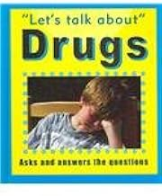  ‘Bottled’ - Jo and Tom Brassington  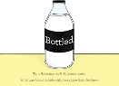 | *actions affect themselves and others  *consequences of bullying and violent behaviour  *challenge stereotypes  *identify own worth and achievements  *diverse relationships  Perfectly Norman - Tom Percival  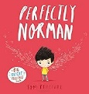  My shadow is pink - Scott Stuart  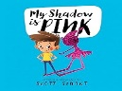  ‘They’ - Chantal Reardon  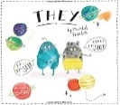  Trolls stink - Jean Willis  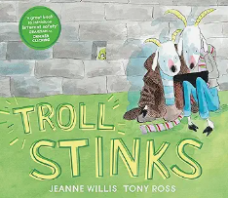 | Bikeabilty | Hygiene routines as part of S.R.E | *problem solving embarrassing situations  *bodily and emotional changes at puberty  *types of relationships  *emotional health and well being  *understanding homophobia  *having a baby |  |  |  | *effects of smoking  *alcohol and the media’s influence  *all medicines are drugs but not all drugs are medicines  *supermarket influence on and alcohol purchases  The littlest yak - Lu Fraser  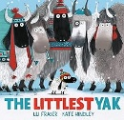 |  |  |  |  | *how democracy works  *bills and parliament  *human behaviours  *nature of crime  *role of the police  Looking after Britain - Christopher Yeates  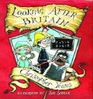  If I were prime minister  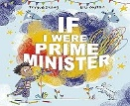 | *money, saving, spending and budgeting  *empathy towards people about money and costs  Why money matters - Deborah Meaden  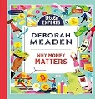  The wrong shoes - Tom Percival  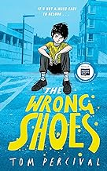 | *anti -social behaviour  *peer pressure  *risky behaviours  *carrying knives/ consequence  My Path - Jana Curll  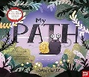  The wrong shoes - Tom Percival

