Croyland Primary School-Geography Long Term Plan: Lower KS2

Year 3 Learning |  |  | Year 4 Learning
Mapping | Europe | Transportation | Europe | Natural Disasters | UK study - physical
Curriculum maps used

Describing maps of the world: 1  Describing maps of the world: 2  Describing maps of the world: 3 | Europe human geography – population and places | Transportation – cities  Transportation – national  Transportation – international | Europe physical geography  Europe – rivers  Europe – mountains | Earthquakes and volcanoes – plate tectonics  Earthquakes and volcanoes – Pacific Ring of Fire  Earthquakes and volcanoes – impact | Landscapes – weathering  Landscapes – rivers  Landscapes – mountains
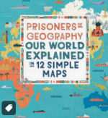  Our world explained in 12 Simple Maps -  Tim Marshall  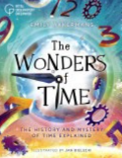  The wonders of time -  Jan Bieleki Emily Akkermans | 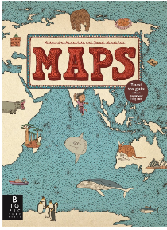  Maps by Aleksandra Mizielinska and Daniel Mizielinski | 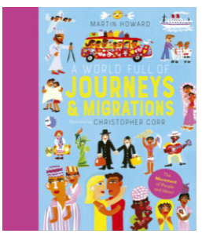Journeys and Migrations by Christopher Corr and Martin Howard | 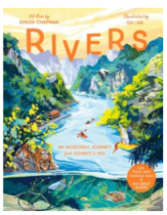  Rivers by Qu Lan and Simon Chapman  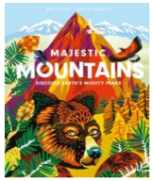  Majestic Mountains by Marcos Navarro and Mia Cassany | 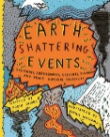  Earth Shattering Events -  Robin Jacobs & Sophie Williams | 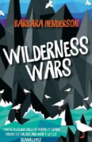  Wilderness wars  Barbara Henderson
Knowledge Categories |  |  | Knowledge Categories
  Techniques | 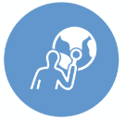  Location | 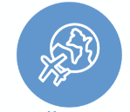  Human Processes | Location | 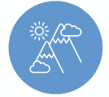  Physical Features | 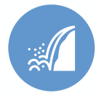  Physical Processes
 |   Diversity | Techniques | Diversity | Physical Processes | Human Processes
 | Physical Features | 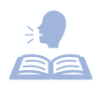  Vocabulary | Physical Features | Location | Physical Features
 |   Human Features |  | Human Features | Vocabulary | Human Features
 | Vocabulary |  | Vocabulary |  | Vocabulary
Making links with: |  |  | Making links with:
The World (Y1) | Continents and oceans (Y2) | Trade (Y6) | Europe (Y3) |  | Countries and Capitals of the UK (Y2)
Top Tips: |  |  | Top Tips:
Use a range of atlases and the maps we have around school during this topic. It is important that the children see different perspectives of the world from the different maps and atlases. | Use PHILLIPS (new) atlases to show children information on Europe.  Pg 50-51 Europe  Use WAYLAND (old) atlases  Pg 40-43 Europe  Use COLLINS atlases (older)  Pg 27-33 Europe (countries and landscapes) | Use PHILLIPS (new) atlases to show children information on  Transportation.  Pg 16-17 Transport UK  Pg 42-43 Transport and tourism  Use WAYLAND (old) atlases  Pg 28-29 Transportation | Use PHILLIPS (new) atlases to show children information on Europe.  Pg 50-51 Europe  Use WAYLAND (old) atlases  Pg 40-43 Europe  Use COLLINS atlases (older)  Pg 27-33 Europe (countries and landscapes) | Use PHILLIPS (new) atlases to show children information on Europe.  Pg 38-39 Volcanoes and Earthquakes  Use COLLINS atlases (older)  Pg 66-67 World Earthquakes and volcanoes  May be a longer topic | Use PHILLIPS (new) atlases to show children information on UK Study  Pg 6-27 UK and Ireland  Use WAYLAND (old) atlases  Pg 32-39 British Isles  Use COLLINS atlases (older)  Pg 8-26 UK and Ireland
Fieldwork Suggestions |  |  | Fieldwork Suggestions
Fieldwork suggestions:  The Embankment  -Take a walk along the river  -Record what features they may spot beside the river.  -Back in class: look at the River Nene on a map see how far it stretches and show the children the small part of the river we looked at. | Fieldwork suggestions: Trip to Northampton  - Get the local bus. Discuss transport in local area  - Sketch and make note of local attractions and human features (bus/train stations), theatres, housing/hotels, transport links  - Undertake interviews with local people (pre-prepared questions)  - Use digital and Arial photos to observe change in human features over time  - Back in class, compare to areas/cities in Europe | Fieldwork suggestions: Wellingborough train station  - Look at transportation within cities  - Study congestion, popularity of routes available  - Observe those driving, cycling, getting a taxi to train station to board train  - Interview local people about their journeys and frequency of travel choice  Northampton Road  Take children up to Northampton Road to monitor and record traffic (Lorries, Cars, Bikes, Walking) |  |  | Fieldwork suggestions: Wellingborough Embankment, Irchester Country Park  - use digital and Ariel photos  - use maps and symbols to navigate around  - make sketches of physical features, hilly areas, weathered areas (erosion), rivers etc  Field trip to be completed while children are on residential at Ilam Hall.
Diversity |  |  | Diversity
-Show children a range of maps the Mercator projection map (standard map you see) size countries have been enhance but not others.  -Show children peters projection map to see the real sizes and scale of countries.  - encourage children to discuss where they are from and share knowledge of that culture. | - encourage children to discuss where they are from and share knowledge of that culture. | As much as possible, make sure you provide a balanced, global overview of countries and cultures around the world | - encourage children to discuss where they are from and share knowledge of that culture.
Developing Cultural Capital |  |  | Developing Cultural Capital
Discuss: What maps do you see on a daily basis? Refer to maps children will see in school.  POP Task: Children to apply their knowledge of map techniques to describe the locations of:  -Four capital cities of UK  -Our School  -Our local area. | Discuss: What are the key landmarks in Europe? Look at the geographical locations of each. Compare Europe’s landmarks to landmarks we have in England  POP Task: Choose 2 European countries and England and compare key phrases in the languages. | Discuss: What are England doing to try and reduce pollution (talk about London with congestion charges and low emissions.  POP Task: Compare what Wellingborough has to offer, transport wise, and compare to another country (link to European town that has metro) | Discuss: What are the key landmarks in Europe? Look at the geographical locations of each. Compare Europe’s landmarks to landmarks we have in England  POP Task: Compare the food eaten between 2 different European countries and what traditional foods are eaten in England. | Discuss: Earthquakes and volcanoes usually fall on the plate tectonics but do not always. Look at the closest volcano/earthquake that has happened near Wellingborough.  POP Task: Plot on a map where any UK earthquakes have been felt – the epicentre and the spread. | Discuss: What are our most famous UK landmarks. Does each city have the same number?  POP Task: compare and contrast other areas of the UK with Wellingborough. Discuss similarities and differences with reference to human and and physical geography

RESOURCES

Year 3

Mapping:
- (time zones) https://www.youtube.com/watch?v=-j-SWKtWEcU
- (tropics of Cancer and Capricorn) https://www.youtube.com/watch?v=MLfrjRi-cbQ

Europe:
- (human geography Europe overview) https://www.youtube.com/watch?v=RNx0akt3_XI
- (countries of Europe) https://www.youtube.com/watch?v=07Zoc5fgoOA
- (exploring Europe) https://www.youtube.com/watch?v=Zs_DldO_G1w

Transportation:
- (different types of transport in cities) https://www.youtube.com/watch?v=tSvSUdZOjLo

Year 4
Europe:
- (mountains of Europe, pause throughout to discuss country location) https://www.youtube.com/watch?v=7M0chp-Rd50
- (rivers of Europe, pause throughout to discuss country location) https://www.youtube.com/watch?v=0A_CK8qR8Tk
- (physical Europe and climate, pause throughout to discuss) https://www.youtube.com/watch?v=IT0MZLpNoIg
Natural disasters:
- (mountains, volcanoes and earthquakes) https://www.youtube.com/watch?v=S9ty-ta1wyI
- (earthquakes) https://www.youtube.com/watch?v=Q-v-G1iL67w
- (volcanoes) https://www.youtube.com/watch?v=lAmqsMQG3RM
UK study – physical:
- (physical geography UK) https://www.youtube.com/watch?v=mL1RsDRvTig
- (mountain ranges in Britain and N Ireland ) https://www.youtube.com/watch?v=c58_nibB4vU
- (major rivers of UK) https://www.youtube.com/watch?v=AMu5D6ToZv8

