Croyland Primary School – Long Term Overview –2024/2025
 | Term 1  7 weeks 5 days |  | Term 2  6 weeks 4 days |  | Term 3  5 weeks 3 days |  |  | Term 4  6 weeks | Term 5  4 weeks 2 days | Term 6  7 weeks 2 days
Theme | All about us! |  | Celebrations |  | The World Around Us |  |  | Traditional Tales | Come Outside | Who helps us?
Curriculum Intent | Children will understand their own identity and their role of being part of a class. They know the similarities and different between where they live and where others live. |  | Children will learn about similarities and differences between themselves and others, and among families, communities and traditions. |  | Children will learn about the change in the weather and how to dress appropriately in this country and contrasting countries.  Children learn about the past and present through toys, books and photos. |  |  | Children will learn about traditional tales and begin to form their own opinions. | Children will make observations of animals and plants and explain why some things occur, and talk about changes. | Children will learn about different occupations and ways of life.
Writing Themes  Core Texts  Storytime Books | Pete the Cat  The Colour of Us  In Every House in Every Street  Houses and Homes  Colour Monster  We’re Going on a Bear Hunt  Aliens Love Underpants  On the Way Home  Rosie’s Walk  Frokodile |  | Pumpkin Soup  The Best Diwali Ever  Sparks in the Sky  Kipper’s Party  Nativity Story  The Jolly Christmas Postman  Room on the Broom  Cotton Wool Colin  The Squirrels Who Squabbled  The Proudest Blue  Dave and the Tooth Fairy |  | Jack Frost  Seren’s Seasons  Lost in a Toy Museum  Then and Now  As We Grow  The Great Race  My Monster and Me  Amy Wu and the Patchwork Dragon  Six Dinner Sid  One Snowy Night  The Wonky Donkey |  |  | The Gingerbread Man  Three Little Pigs  Jack and the Beanstalk  Goldilocks and the Three Bears  You Choose A Fairy Tale  Billy and the Beast  We’re going to find a monster  Little Red  Tiddler  The Giant Jam Sandwich | The Tiny Seed  Jasper’s Beanstalk  The Extraordinary Gardner  Hungry Caterpillar  How does a frog grow  Mad About Mini Beasts  Billy’s Bucket  Handa’s Hen  Sonya’s Chickens  How to Grow a Dinosaur  Elmer | Supertato  Dr Ranj – A Superpower like mine  Dr Ranj – A Superhero like you  Clothes Line Clues  When I Grow Up  The Mega Magic Teacher Swap  The Scarecrows Wedding  Ruby’s Worry  Eco Girl  Look Up  Give Us a Smile Cinderella
Special Events and Celebrations |  |  | Halloween -31st Oct  Bonfire Night-5th Nov  Diwali – 8th November  Hannukah – 4Th December  Christmas – 25th Dec |  | Chinese New Year – 17th feb  Shrove Tuesday – 17th feb  Mothers Day – 15th March  Ramadan - 17th feb  Eid – 18th March  Easter – 5th April |  |  |  | Fathers Day – 21st June
Hook and  Enrichment Opportunities | Starting school  Finding out children’s interests. Using these to engage learning.  Chatter Bags – all about me. |  | Visit to the Pantomime  Chatter Bags – photo of a family celebration.  Cooking – Pumpkin soup  Church visit. Walk to St Barnabas Church.  Nativity Experience |  | Visit Wellingborough Museum  Visits from Grandparents/Great Grandparents  Old and New Toys  Toys from other cultures and countries  Chatter Bags – Pictures of children as a baby and now.  Cooking – Balance buns |  |  | Visit to Wellingborough Library  Baking- Gingerbread Men | Walk to Morrisons – healthy eating.  Making fruit kebabs  Planting seeds  Caterpillars/Butterflies | Visits from People Who Help Us  -Fire fighters  -Police  -Dentist  -Nurse  etc  Posting a letter  Baking bread  Dress Up Day – What do you want to be when you grow up?
Parental Engagement | Stay and Play – settling into school, what have been learning?  Phonics information session |  | Nativity Experience  School Lunch with parents |  | Maths Stay and Play |  |  | Easter Stay and Play | Nature Explorers Stay and Play | Sports Day
PSED | Key Learning Foci:  - Valued individual – The Colour of Us  - 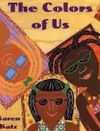  - Making new relationships  - Introduce values:  - Be ready  - Be respectful  - Be safe  - Hand Washing |  | Key Learning Foci:  - Recognising our feelings/Self -Regulation  - Sharing/The perspective of others – The Squirrels Who Squabbled  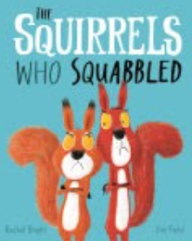  - Listening to and following instructions |  | Key Learning Foci:  - Recognising others feelings – My Monster and Me  - 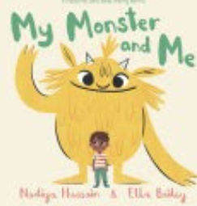  - Road Safety  - Good routines – screen time/bed time |  |  | Key Learning Foci:  - Developing resilience – Billy and the Beast  - Nadia Shireen  - 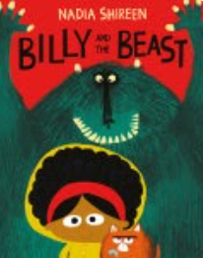  - Pants Rule | Key Learning Foci:  - Respond appropriately to feelings of others  - Healthy Eating | Key Learning Foci:  - Moving on – Ruby’s Worry  - 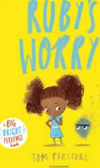  - Transitions – The Mega Magic Teacher Swap  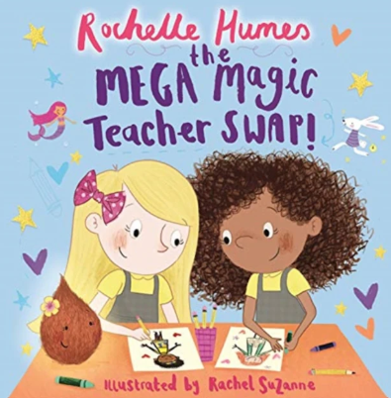  - Brushing Teeth – Give us a smile Cinderella  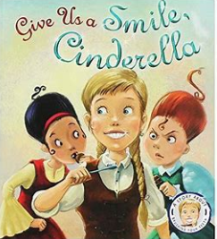  - Staying safe online
Communication and Language | Key Learning Foci:  - Listening skills during group/class sessions  - Learn simple songs  - Joining in with repeated refrains |  | Key Learning Foci:  - Talking about the plot and main problem in a story  - Introducing connectives when speaking in sentences.  - Learning rhymes |  | Key Learning Foci:  - Identifying the main characters in a story - talk about feelings, actions, motives  - Explaining why things work and how they happen.  - Describing events in detail. (Recount of walk) |  |  | Key Learning Foci:  - Linking events in a story to own experiences  - Retelling a story | Key Learning Foci:  - Asking questions to find out more.  - Listening to and talk about non-fiction | Key Learning Foci:  - Introducing poetry
New vocabulary is continually introduced. Talk is modelled and scaffolded by adults during quality interactions.
Physical Development | Key Learning Foci:  - Line Dancing Mr Mc  - Develop pencil grip  - Use scissors to make snips  - Adults to support lunchtime (Using knife and fork)  - Introduce equipment in the outdoor space  - Teach safe and controlled use of bikes and scooters  - Children to learn how to line up.  - Indoor PE: Pilates Skills taught: Sitting still, core strength, balance, coordination) |  |  | Key Learning Foci:  - Line Dancing Mr Mc  - Use scissors to cut a straight line.  - Introduce Hammers (pumpkins)  - Using knives to chop vegetables  - Large scale mark making using paint/chalk/water  - Controlling balls/rolling balls.  - Indoor PE: Gymnastics  - Skills taught: Travelling, rolling, balancing, jumping, hopping, skipping) | Key Learning Foci:  - Develop ball control- bounce, throw, catch and kick.  - Use scissors to cut more complex shapes  - Hold pencil with a tri pod grip.  - Indoor PE: Dance (Toys) Skills taught – coordination, sequencing movements, agility, balance) |  |  | Key Learning Foci:  - Develop ball skills – batting, passing and aiming.  - Indoor PE: Gymnastics equipment: balance, moving across equipment, climbing, crawling. | Key Learning Foci:  - Introduce gardening tools  - Using knives to chop fruit  - Indoor PE: Yoga Skills taught: Core strength, coordination, balance | Key Learning Foci:  - Complete drawing tutorials to encourage precision and accuracy.  - Outdoor PE: Sports Day preparation
Physical development is woven through the continuous provision throughout the year.
Handwriting and letter formation also forms part of our Literacy curriculum.
Literacy | Key Learning Foci:  - Story telling  - Nursery Rhymes  - Introduction of phonics - first set of sounds  - Oral blending (Fred talk)  - Magnetic boards to build words.  - Mark making.  - Name writing.  - Saying and writing initial sounds. |  |  | Key Learning Foci:  - Story telling using newly introduced vocabulary.  - Continue introducing set 1 sounds including special friends (sh,ch, th, nk, ng)  - Letter formation of sounds introduced  - Introducing hold a sentence.  - Introduction of spelling (Using Fred fingers) |  |  | Key Learning Foci:  - Anticipate key events in stories.  - Non-Fiction  - Reading captions (ditties)  - Segmenting and blending (fred talk)  - Reading nonsense words (alien words)  - Letter formation (on lines if appropriate)  - Caption and label writing.  - Introduction of finger spaces.  - Begin to write red words. | Key Learning Foci:  - Non-fiction/Fiction  - Introduce set 2 sounds (ay, ee, igh, ow, oo)  - Writing a simple sentence  - Introduction of capital letters and full stops. | Key Learning Foci:  - Fiction/Instructions  - Reading books with short stories. | Key Learning Foci:  - Use and understand recently introduced language during storytelling.  - Poetry  - Reading longer stories  - Consolidation of all skills taught throughout the year.
Phonics/Reading is taught through the RWI scheme of work. Writing and reading opportunities available through continuous provision.
Maths |  | Key Learning Foci:  - Match sort and compare  - Talk about measure and pattern  - Its me 1, 2, 3  - Circles and Triangles  - 1, 2, 3, 4, 5  - Shapes with 4 sides |  |  |  | Key Learning Foci:  - Alive in 5  - Mass and Capacity  - Growing 6, 7, 8  - Length, Height and Time  - Building 9 and 10  - Exploring 3D Shapes |  |  | Key Learning Foci:  - To 20 and beyond  - How many now  - Manipulate, compose and decompose  - Sharing and grouping  - Visualise, build and map  - Make Connections
Maths is taught through the White Rose scheme of learning. Maths resources available through continuous provision.
 |  | Who are the members of our family and community? -chatter bags.  Can you name and describe people who are familiar to you? – family photos  How do we draw information from a simple map?  Where do we live? Looking at the local area and local surroundings.  What are the similarities and differences between this county and life in other countries?  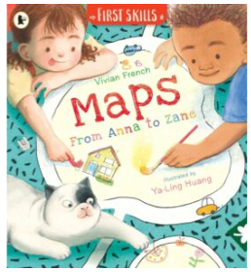  From Anna to Zane  Vivian French  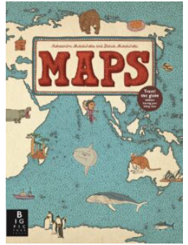  Maps  Aleksandra Mizielinska,Daniel Mizielinski |  | Why do people have different beliefs and celebrate these in different ways?  Why are some places special to members of our community?  What natural processes can you observe and interact with? --Melting  What do people celebrate around the world? Celebrations – Diwali, Christmas  Where do we belong?  Best Diwali Ever  Sonali Shah  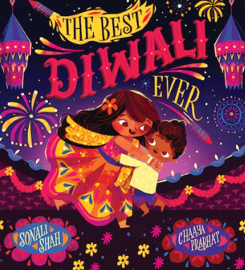  Sparks in the sky  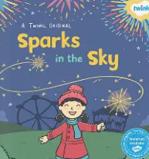  Twinkl Original |  | How is the past similar or different to how we live?  How are characters from stories different or the same as people we know?  What natural processes can you observe and interact with?–light travelling through materials  What traditions do you and your family have? (Olaf video)  Then and Now  Usbourne  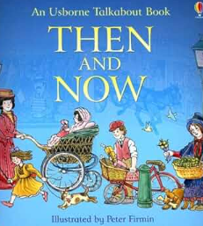  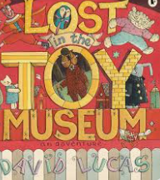  Lost in the Toy Museum  David Lucas |  | What natural processes can you observe and interact with?-Floating/sinking  What books are special to people?  Bible and Quran  Who created the world? What do you think? | Can you drawing pictures of the natural world – plants and animals?  How are environments different from the one in which they live? – natural/man made  How is the natural world changing and what processes are happening?  How do things grow?  What lives in our outdoor area?  What natural processes can you observe and interact with?- natural processes – Magnets  What books are special to people?  Bible and Quran | Who are people that help us in our community?  What group do you belong to?  What can we learn from stories from different religions?  What natural processes can you observe and interact with? Making shadows
Nature Explorers |  | Egg Box Matching |  | Observing the change in seasons. (Leaf Thief)  Natural Crowns |  | Observing the change in seasons – Winter  Introduce Fire – marshmallows |  | Natural Art  Bird Feeders | Talk about the natural environment – naming trees  The Very Hungry Caterpillar | Den building
Understanding the World enhancements are woven through the continuous provision and Nature Explorer sessions throughout the year:
Understand the effect of changing seasons on the natural world around them
Describe what they see, hear, and feel whilst outside.
Children are included in development of outdoor area in line with changing seasons
All children will attend nature explorers across the year.
Children will also be ‘working scientifically’ throughout the curriculum, asking and answering questions, using talk to work out problems and organise thinking. Explain how things work and why they might happen and make comments about what they have heard and ask questions to clarify their understanding.
Expressive Arts  and Design |  | Key Foci:  - Exploring shades and tones. Self-portrait. Frida Kahlo.  - Using hands and feet to print. Name primary colours.  - Using glue sticks and pre-cut paper to create collage.  - Exploring percussion instruments.  - Using sounds to represent emotions |  | Key Foci:  - Mixing primary colours. Use thick and thin brushes.  - Moulding with clay. Diva lamps.  - Printing using sponges/ vegetables Harvest  - Movement and listening games.  - Singing – matching pitch and following a melody.(Nativity Experience) |  | Key Foci:  - Using cotton buds to paint. George Seurat: pointillism.  - Joining methods: adhesive tape  - Using bodies to keep a steady beat.  - Drawing to represent ideas like movement or loud noises. |  | Key Foci:  - Adding water to paint to make a wash. Landscapes.  - Creating rubbings.  - Drawing with complexity and detail using a range of tools.  - Expressing feelings & responses to music/dance/performance art.  - Inventing and adapting stories. | Key Foci:  - Large scale drawing.  - Georgia O’Keefe: flowers.  - Printing using natural materials.  - Returning to work to edit and improve.  - Using uncut materials to create a collage. The Snail, Matisse | Key Foci:  - Choosing or mixing colours for a purpose.  - Printing a repeating pattern.  - Showing different emotions in drawings.  - Collaborative splatter painting. Pollock  - Engaging and performing in music making and dance – solo or in groups.
Expressive Arts and Design enhancements are woven through the continuous provision throughout the year

