Science LTP
 | EYFS
 |  | Changing states of matter |  | Healthy Eating, lifestyles and teeth  Changing states of matter | Understand important processes and changes in the natural world
Understanding the World enhancements are woven through the continuous provision throughout the year:
Understand the effect of changing seasons on the natural world around them
Describe what they see, hear, and feel whilst outside.
Children are included in development of outdoor area in line with changing seasons
Children will also be ‘working scientifically’ throughout the curriculum, asking and answering questions, using talk to work out problems and organise thinking. Explain how things work and why they might happen and make comments about what they have heard and ask questions to clarify their understanding
Class | Unit 1 |  | Unit 2 | Unit 3 |  | Unit 4 |  | Unit 5 |  | Unit 6
Year 1 | Animals including  Humans.  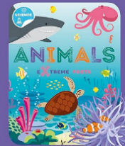  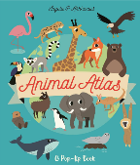  Animal Atlas by Ingela P. Arrhenius  Animals (Extreme Facts) by Steffi Cavell-Clarke  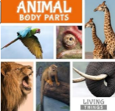  Animal Body Parts by Steffi Cavell-Clarke (P6) |  | Everyday materials  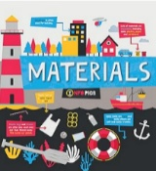  Materials by Harriet Brundle | Plants  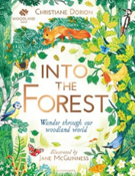  The Woodland Trust: Into the Forest by Christiane Dorion  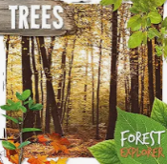  Trees by Robin Twiddy
Year 1 | Seasonal changes  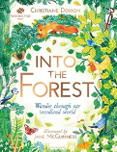  The Woodland Trust: Into the Forest by Christiane Dorion  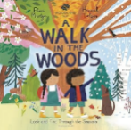  A Walk in the Woods by Flora Martyn |  | Seasonal changes  The Woodland Trust: Into the Forest by Christiane Dorion  A Walk in the Woods by Flora Martyn | Seasonal changes  The Woodland Trust: Into the Forest by Christiane Dorion  A Walk in the Woods by Flora Martyn |  | Seasonal changes  The Woodland Trust: Into the Forest by Christiane Dorion  A Walk in the Woods by Flora Martyn
Year 2 | Living things and Habitats  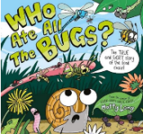  Who ate all the bugs by Matty Long |  | Animals including  Humans  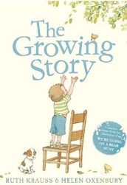  The Growing Story by Ruth Krauss | Everyday materials  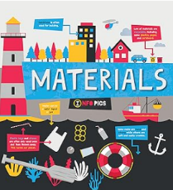  Materials by Harriet Brundle |  | Plants  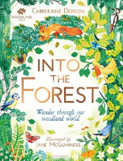  The Woodland Trust: Into the Forest by Christiane Dorion
Year 3 | Animals, including humans  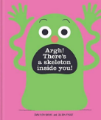  Argh! There is a Skelton inside you.  by Idan Ben-Barak. |  | Rocks  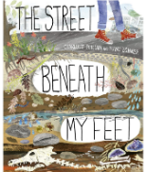  The street beneath my feet Charlotte Guillain  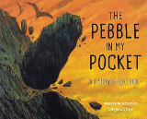  The Pebble in My Pocket: A History of Our Earth by Meredith Hooper | Light  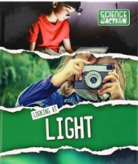  Looking at light by John Wood  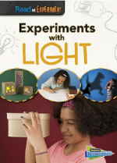  Experiments with Light (Read and Experiment) by Isabel Thomas |  | Forces & Magnets  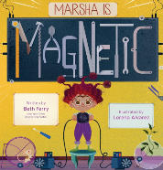  Marsha Is Magnetic by Beth Ferry |  | Plants  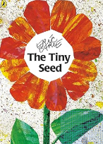  The Tiny Seed by Eric Carle  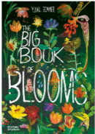  The Big Book of Blooms by Yuval Zommer
Year 4 | All Living Things  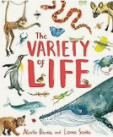  The variety of life by Nicola Davies  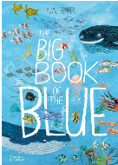  The Big Book of the Blue: Yuval Zommer |  | Animals, including humans  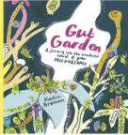  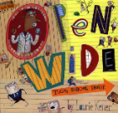  Open wide. Tooth school inside by Laurie Keller  Gut Garden: A Journey into the Wonderful World of Your Microbiome by Katie Brosnan | States of Matter  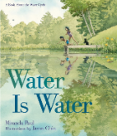  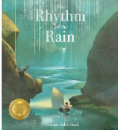  Water is Water by Miranda Paul and Jason  Chin Rhythm of the Rain by Grahame  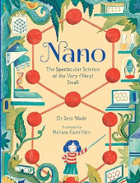  Nano: The Spectacular Science of the Very (Very) Small |  | Sound  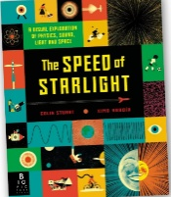  The speed of starlight by Colin Stuart |  | Electricity  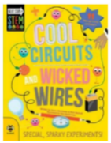  Cool Circuits and Wicked Wires by Susan Martineau
Year 5 | Living things and Habitat  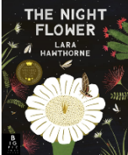  The Night Flower by Lara Hawthorne |  | Animals including Humans | Properties and Changing Materials  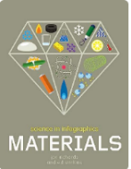  Science in Infographics: Materials  by Jon Richards |  | Earth and Space  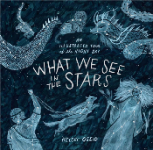  What We See in the Stars: An Illustrated Tour of the Night Sky in the stars |  | Forces  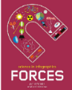  Science in Infographics  Forces by Jon Richards and Ed Simkins
Year 6 | Living things and Habitats  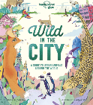  Wild in the City by Kate Baker |  | 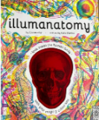  Animas Including humans  Illumanatomy: See inside the human body with your magic viewing lens | Evolution and inheritance  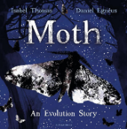  Moth by Isabel Thomas  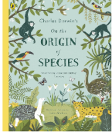  On the origin of species by Sabina Radeva  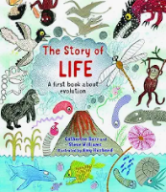  The Story of Life by Catherine Barr |  | Light  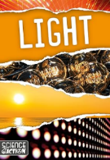  Light by Joanna Brundle  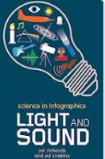  Science in infographics  Light and Sound by Jon Richards and Ed Simkins  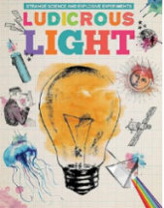  Ludicrous Light (Strange science and explosive experiments) |  | Electricity  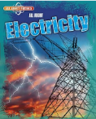  All about Electricity by Leon Gray  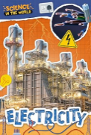  Electricity by Joanna Brundle

------ Living Things ------ Materials and Properties ------ Physical Processes

