Year 1 Learning
Topic | Ancient Art | Weather | In the Jungle
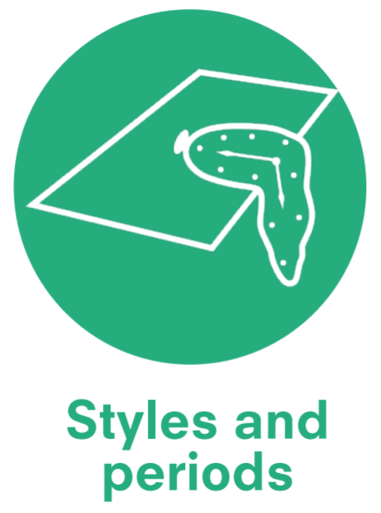 | Ancient Art  4000 B.C. – A.D. 400 | Romanticism  Late 18th and early 19th century | Post Impressionism
 | The Mesopotamians | J.M.W Turner (1775 – 1851) British landscape painter | Pablo Picasso (1881-1973) Spanish Painter  Henri Rousseau (1844-1910) French Painter  Edward Tinga Tinga  (1932 – 1972)  Tanzanian Painter
Knowledge Categories |   Media and materials |   Colour theory | Media and materials
Knowledge Categories |   Emotions |   Emotions |   Techniques
Knowledge Categories |   Techniques |   Visual Language | Emotions
Knowledge Categories | Visual language |   Effects | Visual Language
Knowledge Categories | 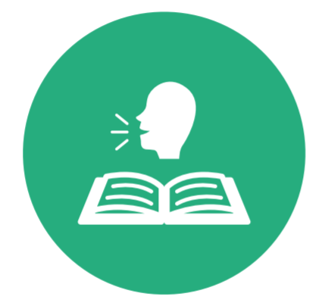  Vocabulary | Techniques | Vocabulary
Knowledge Categories |  | Vocabulary | Colour theory
Knowledge Categories |  |  | Effects
Knowledge Categories |  |  |   Process
Master practical skills
Techniques | Techniques | Media and materials
Media and materials |   Colour theory | Effects
 | Effects | Colour theory
Drawing  - Use charcoal and/or crayon to create an intended effect. | Paint  - Use tools and techniques to experiment with texture, colour and light.  - Experiment with different speeds of brushstrokes. | Collage  - Use a combination of materials that are cut, torn and glued.  - Sort and arrange materials.
Sculpture  - Include lines and texture using clay.  - Use techniques such as moulding and carving. | Drawing  - Draw lines of different sizes and thicknesses.  - Show pattern and texture. | Print  - Use repeating or overlapping shapes.  - Mimic print from the environment (e.g. wallpapers).  - Use objects to create prints (e.g. fruit, vegetables or sponges).  - Press, roll, rub and stamp to make print.
Paint
- Add white to colours to make tints and black to colours to make tones.

Potential opportunities for cultural capital
 | Display work for parent/carers in whole school gallery. | Walk to Croyland Gardens.

Year 2 Learning
Topic | Love for Landscapes | Food | At the Seaside
 | Combination of Styles & Periods | Contemporary Art & Post Impressionism | Impressionism
 | Jacob van Ruisdael (1629-82)  Dutch painter  Katsushika Hokusai (1760-1849) Japanese painter and printmaker  John Constable (1776-1837)  English Romantic painter  Camille Pissarro (1830-1903)  French  John Ndambo (1967-Present) African painter from Kenya | Giuseppe Arcimboldo (1526 – 1593) Italian portrait artist  Johannes Vermeer (1632 – 75) Dutch Baroque artist  Paul Cézanne (1839 – 1906) French post-impressionist painter  Carl Warner (born 1963) British contemporary artist and photographer  Jason Mecier (born 1968) American contemporary artist | Joseph Turner (1775-1851) English Romantic  Edgar Degas (1834-1917) French Impressionist  Claude Monet (1840-1926) French Impressionist  Anthony Gormley (born 1950) British sculptor
Knowledge Categories | Effects | Emotions | Colour theory
Knowledge Categories | Media and materials | Effects | Techniques
Knowledge Categories | Colour theory | Visual Language |   Process
Knowledge Categories | Visual Language | Process | Effects
Knowledge Categories |   Process | Techniques | Visual Language
Knowledge Categories | Vocabulary | Vocabulary | Vocabulary
Master practical skills
Effects | Media and materials | Colour theory
Techniques | Effects | Techniques
 | Colour theory | Effects
Drawing  - Create a quick sketch in preparation for painting. | Paint  - Experiment with layers of colour and different brushstrokes. |  | Paint  - Using brushstrokes to suggest movement.  - Texture mixing – sand and paint.  - Explore using different thicknesses and blobs of paint to create different effects.
Paint  - Use thick and thin brushes. Apply a wash. Experiment with white tinting. | Print  - Use objects to create prints (e.g. fruit or vegetables).  - Press, roll, rub and stamp to make print. |  | Sculpture  - Use a combination of shapes.
Collage
- Use a combination of materials that are cut, torn and glued.
- Sort and arrange materials.
- Mix materials to create texture.
Potential opportunities for cultural capital

 | Walking trip to Morrisons.  Display work for parent/carers in whole school gallery. |  | Trip to the sea life centre.

