Key Stage 1
 | Term 1 | Term 2 | Term 3 | Term 4 | Term 5 | Term 6
 | 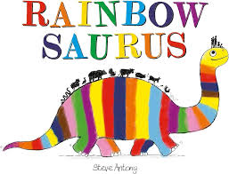  Fiction: Story  Purpose: Entertain | 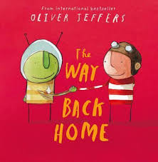  Fiction: Science Fiction  Purpose: Entertain  Non-fiction: Instructions – how to fix a plane/how to make a rocket  Purpose: To inform | 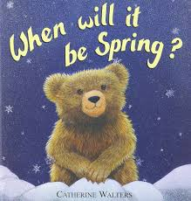  Fiction: Story  Purpose: Entertain  Non-fiction: NCR – Seasons  Purpose: To inform | 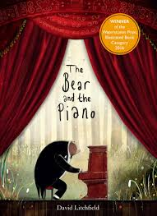  Fiction: Adventure  Purpose: Entertain  Non-fiction: Poetry  Purpose: To entertain | 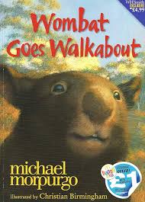  Fiction: Adventure  Purpose: Entertain  Non-fiction: Explanation text  Purpose: To inform | 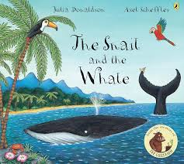  Fiction: Adventure  Purpose: Entertain  Non-Fiction: Recount (Diary)  Purpose: To inform
 | 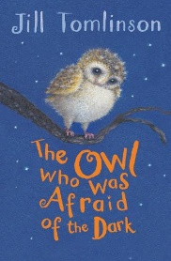  Fiction: Adventure  Purpose: To entertain  Non-Fiction: Non-Chronological Report  Purpose: To inform | 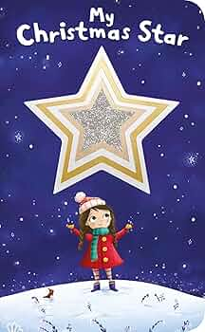  Fiction: Story  Purpose: To entertain  Non-Fiction: Letter – Christmas performance  Purpose: Inform | 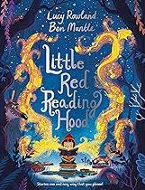  Fiction: Traditional tale with a twist  Purpose: To entertain  Non-Fiction: Recount – library visit  Purpose: Inform | 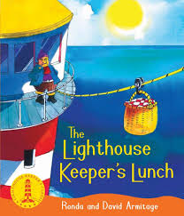  Fiction: Story  Purpose: To entertain  Non Fiction: Instructions- How to make a sandwich  Purpose: Inform | 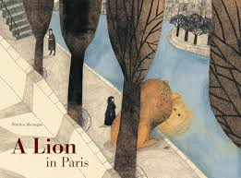Fiction: Adventure  Purpose: To entertain  Non Fiction: Non Chronological report - Paris  Purpose: Inform | 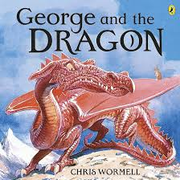Fiction: Legend  Purpose: To entertain  Non Fiction: Instructions – How to catch a dragon.  Purpose: Inform

Lower Key Stage 2
 | Term 1 | Term 2 | Term 3 | Term 4 | Term 5 | Term 6
Y3 | 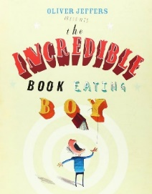  Fiction: Comedy  Purpose: To entertain  Non Fiction: Newspaper report  Purpose: To inform | 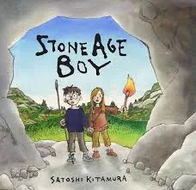  Fiction: Story  Purpose: To entertain  Non Fiction: Instructions – How to hunt an animal  Purpose: To inform | 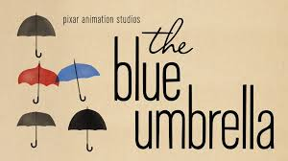  Fiction: Romance  Purpose: To entertain  Non Fiction: Poetry - Haiku  Purpose: To entertain | 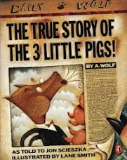  Fiction: Traditional tale with a twist  Purpose: To entertain  Non Fiction: Letter  Purpose: To inform | 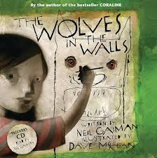  Fiction: Suspense  Purpose: To entertain  Non Fiction: Non-chronological report  Purpose: To inform | 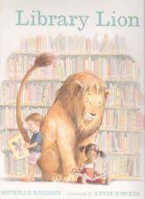  Fiction: Story  Purpose: To entertain  Non Fiction: Poetry  Purpose: To entertain
Y4 | 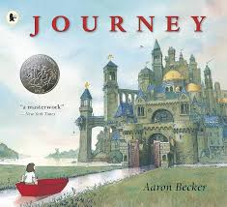  Fiction: Adventure  Diary – written in the role of a character  Non Fiction: Letter – to parents  Purpose: To recount | 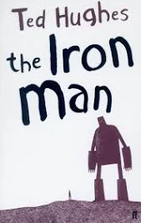  Fiction: Science fiction  Purpose: To entertain  Non Fiction: Instructions – how to trap the iron man  Purpose: To inform | 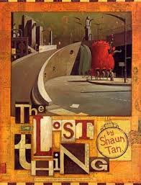  Fiction: Fantasy  Purpose: To entertain  Non Fiction: Non-chronological report – facts about ‘the things’  Purpose: To inform | 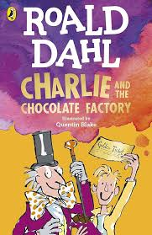  Fiction: Adventure  Purpose: To entertain  Non Fiction: Explanation text – How a sweet machine works.  Purpose: To inform | 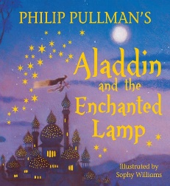  Fiction: Traditional Tale  Purpose: To entertain  Non-Fiction: Persuasive text – magical item advert  Purpose: To persuade | 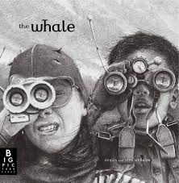  Fiction: Mystery  Purpose: To entertain  Non-Fiction: Newspaper – report – Finding the whale  Purpose: To inform

Upper Key Stage 2
 | Term 1 | Term 2 | Term 3 | Term 4 | Term 5 | Term 6
Y5 | 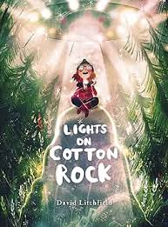  Fiction: Wishing tale  Purpose: To entertain  Non-fiction: newspaper report  Purpose: To inform | 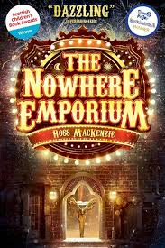  Fiction: Journey tale  Purpose: To entertain  Non-fiction: Persuasive article/leaflet  Purpose: To persuade | 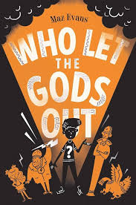  Fiction: Journey tale  Purpose: To entertain  Non-fiction: Explanation about the Earth Stone  Purpose: To inform | 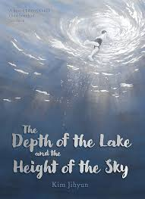  Fiction: Finding tale  Purpose: To entertain  Non-fiction: Non chronological report (countryside)  Purpose: To inform | 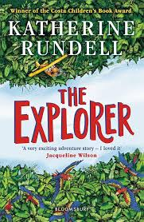  Fiction: Journey tale  Purpose: To entertain  Non-fiction: Instruction writing - survival  Purpose: To inform | 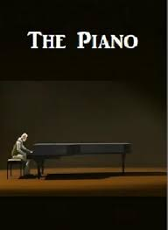  Poetry: Finding tale  Purpose: To entertain  Non-fiction: Diary (recount)  Purpose: To inform
Y6 | 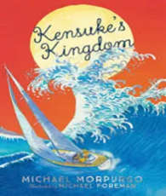  Fiction: Journey tale  Purpose: To entertain  Non Fiction: Instructional texts – Island survival  Purpose: To inform | 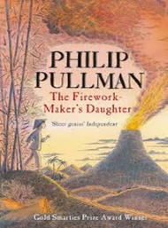  Fiction: Journey Tale  Purpose: To entertain  Non-fiction: Persuasive writing - Become a firework maker  Purpose: To persuade | 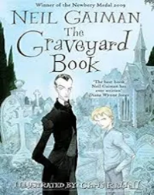  Fiction: Mystery  Purpose: To entertain  Non-fiction: Newspaper Report  Purpose: To inform | 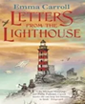  Non-Fiction: Recount  Purpose: To inform  Non-fiction: Non-chronological report – Evacuees of WW2  Purpose: To inform | 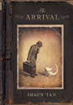  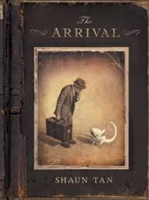  Fiction: Suspense  Purpose: To entertain  Non-fiction: Diary Entry  Purpose: To inform | 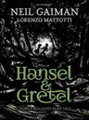  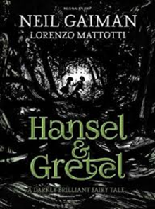  Fiction: Suspense  Purpose: To entertain  Fiction Boost: Alma  Purpose: To entertain  (Describe setting and atmosphere)

