Croyland Primary School-History Long Term Plan: KS1 2023-2024

Year 1 Learning |  |  | Year 2 Learning
Queen Victoria | Christopher Columbus | Wellingborough  (living memory) | Queen Elizabeth II | Moon Landing | The Gunpowder Plot | Wellingborough (Anglo-Saxons)
Knowledge Categories |  |  | Knowledge Categories
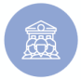  Society | 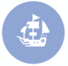  Travel and Exploration | Food and Farming  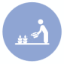 | Society | Travel and Exploration | 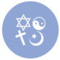  Beliefs | Food and Farming
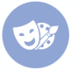  Culture and Past Times | Settlements  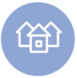 | Settlements | Culture and Past Times | Conflict  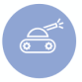 | Settlements | Settlements
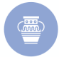  Artefacts | 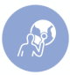  Location | Artefacts | Beliefs | Location | Artefacts | Artefacts
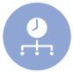  Main Events | Main Events | Main Events | Main Events | Main Events | Main Events | Main Events
Vocabulary  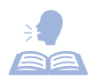 | Vocabulary | Vocabulary | Vocabulary | Vocabulary | Vocabulary | Vocabulary
Making links with: |  |  | Making links with:
 |  |  | Queen Victoria  The Gunpowder Plot | Christopher Columbus  Thanksgiving | Wellingborough (Y2)  Queen Elizabeth II | Wellingborough (Y1)  Thanksgiving
Top Tips: | Top Tips: | Top Tips: | Top Tips: | Top Tips: | Top Tips: | Top Tips:
 | BBC history and bitesize  Web links 1, 2, 3 | Visits to the market/ Morrisons. | Film footage of the Coronation.  Web links 4, 5. | Film footage of the Moon landing.  Web links 6, 7. | Teach at the beginning of November.  Web link 8 | BBC Archives  Wellingborough Museum

