 | Develop ideas   | Master practical skills   | Take inspiration  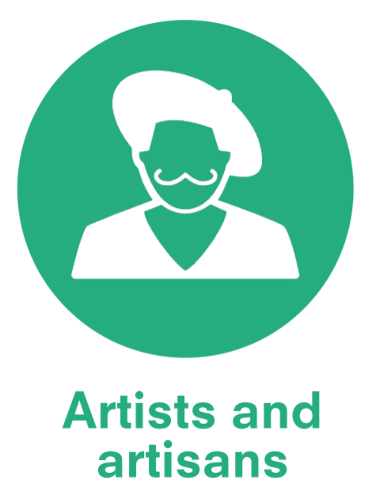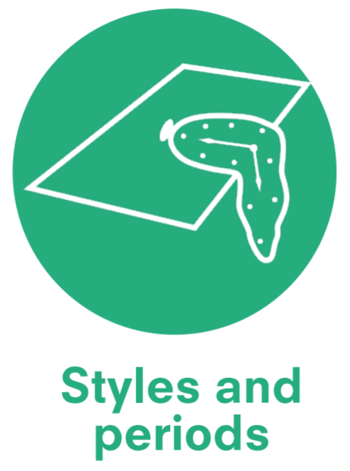 | Vocabulary  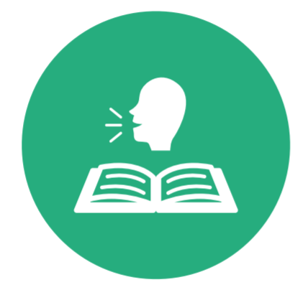
Year R | - Respond to provocations and invitations to learn.  - Explore own ideas.  - Explore different methods and materials. | Paint  - Use a variety of tools including different size brushes and tools.  - Explore what happens when they mix colours.  - Use particular colours for a purpose.  Collage  - Experiment with different textures.  - Manipulate materials to create a planned effect.  Sculpture  - Explore a range of malleable media such as clay, papier-mâché and salt dough.  - Cut shapes using scissors and other modelling tools.  - Construct with a purpose in mind, using a variety of resources.  Drawing  - Draw with complexity & detail.  - Start to produce lines of different thickness using a pencil.  - Draw to represent ideas like movement or loud noises.  - Show different emotions in drawings.  Print  - Take rubbings e.g. leaf, brick and coin.  - Create simple pictures by printing from objects.  - Develop simple patterns by using objects. | - Use some ideas from artists studied to create own art. | - Paint, colour, mix, thick, thin, collage, texture, glue, stick, cut, scissors, tear, shape, clay, carve, tools, cut, draw, pencil, scribble, print, pattern, rubbing, line.
Milestone 1: year 1 and 2 | - Respond to ideas and starting points.  - Explore ideas and collect visual information.  - Explore different methods and materials as ideas develop. | Paint  - Use thick and thin brushes.  - Mix primary colours to make secondary colours.  - Add white to colours to make tints and black to colours to make tones.  - Create colour wheels.  Collage  - Use a combination of materials that are cut, torn and glued.  - Sort and arrange materials.  - Mix materials to create texture.  Sculpture  - Use a combination of shapes.  - Include lines and texture.  - Used rolled up paper, straws, paper, card and clay as materials.  - Use techniques such as rolling, cutting, moulding and carving.  Drawing  - Draw lines of different sizes and thicknesses.  - Colour (own work) neatly following the lines.  - Show pattern and texture by adding dots and lines.  - Show different tones by using coloured pencils.  Print  - Use repeating or overlapping shapes.  - Mimic print from the environment (e.g. wallpapers).  - Use objects to create prints (e.g. fruit, vegetables or sponges).  - Press, roll, rub and stamp to make prints. | - Describe the work of notable artists, artisans and designers.  - Use some of the ideas of artists studied to create pieces. | Year 1:  Surrounded, lush, exotic, foreground, background, contrast, naïve, botanical, illustrations, imagination, specimens, enlarging, unique, exaggerating.  Portray, recede, temperature, drama, balance, horizontal, billowing, landscape, significant, Romantic, expressive, influenced, critic, palette knife, textured.  Advanced, approximately, architecture, ornaments, tragedy, shards, etchings, frayed, governments, tablets, murals, elaborately, trading, mosaics, honour, kiln, styluses.  Year 2:  Still life, rich colours, portrait, Baroque, Post-Impressionist, contemporary, lavish, represent, canvas, layers, broad, imitate, dynamic, abstract.  Imaginary, speciality, dedicating, appreciate, apply, blend, definition, ominous, vastness, rural, preliminary, composition, idyllic, illuminate, impression.  Inspiration, impressionist, romantic, shimmering, founder, exhibited, critic, mentor, deliberately, vibrant
 | Develop ideas | Master practical skills   | Take inspiration | Vocabulary
Milestone 2: Year 3 and 4 | - Develop ideas from starting points throughout the curriculum.  - Collect information, sketches and resources.  - Adapt and refine ideas as they progress.  - Explore ideas in a variety of ways.  - Comment on artworks using visual language. | Paint  - Use a number of brush techniques using thick and thin brushes to produce shapes, textures, patterns and lines.  - Mix colours effectively.  - Use watercolour paint to produce washes for background then add detail.  - Experiment with creating mood.  Collage  - Select and arrange materials for a striking effect.  - Ensure work is precise.  - Use coiling, overlapping, tessellation, mosaic and montage.  Sculpture  - Create and combine shapes to create recognisable forms (e.g. shapes made from nets or solid materials).  - Include texture that conveys feelings, expression or movement.  - Use clay and other mouldable materials.  - Add materials to provide interesting detail.  Drawing  - Use different hardnesses of pencils to show line, tone and texture.  - Annotate sketches to explain and elaborate ideas.  - Sketch lightly (no need to use a rubber to correct mistakes).  - Use shading to show light and shadow.  - Use hatching and cross hatching to show tone and texture.  Print  - Use layers of two or more colours.  - Replicate patterns observed in natural or build environments.  - Making printing blocks (e.g. from coiled string glued to the block).  - Make precise repeating patterns. | - Replicate some of the techniques used by notable artists, artisans and designers.  - Create original pieces that are influenced by studies of others. | Year 3  Social, peasant, bustling, genre, classes, navvies, flourish, precise, gesture, industrial, initial, rough, restricted, opaque, earthy, tinting, charcoal, smear.  Source, livestock, domestic, originally, layered, mythical, fascination, values, strands, motion, anatomy, masterpiece, gradual, illusion, form, commitment, credited.  Random, geometrical, outline, contrasts, transparent, chromatic, physical, pioneer, harmonise, chord, spiritual, trend, amplification, spectrum, hues, gouache.  Year 4  Impression, optically, hatching, linear, cross-hatching, stippling, essence, porcelain, meticulous, graphite, canopy, subtle, charm.  Astronomical, emerged, lunar, flourished, technical, compositional, NASA, conceptual, storeys, optimism, humanity, glorious, seductive  Myths, legends, moral, Pre-Raphaelite, frustrated, props, relics, Baroque, prolific, aristocratic, dynamic, flushed, mineral, dramatise.
Milestone 3: Year 5 and 6 | - Develop and imaginatively extend ideas from starting points throughout the curriculum.  - Collect information, sketches and resources and present ideas imaginatively in a sketchbook.  - Use the qualities of materials to enhance ideas.  - Spot the potential in unexpected results as work progresses.  - Comment on artworks with a fluent grasp of visual language. | Paint  - Sketch lightly before painting to combine line and colour  - Create a colour palette based upon colours observed in the natural or build world  - Use the qualities of watercolour and acrylic paint to create visually interesting pieces  - Combine colours, tones and tints to enhance the mood of a piece  - Use brush techniques and the qualities of paint to create texture  - Develop a personal study of painting, drawing, based on ideas from other artists.  Collage  - Mix textures (rough and smooth, plain and patterned).  - Combine visual and tactile qualities.  - Use ceramic mosaic materials and techniques.  Sculpture  - Show lifelike qualities and real-life proportions or, if more abstract, provoke different interpretations.  - Use tools to carve and add shapes, texture and pattern.  - Combine visual and tactile qualities.  - Use frameworks (such as wire or moulds) to provide stability and form.  Drawing  - Use a variety of techniques to add interesting effects (e.g. Reflections, shadows, directions of light.)  - Use a choice of techniques to depict movement, perspective, shadows and reflection.  - Choose style of drawing suitable for the work (e.g. realistic or impressionistic).  - Use lines to represent movement.  Print  - Build up layers of colours  - Create an accurate pattern, showing fine detail  - Use a range of visual elements to reflect the purpose of the work. | - Give details (including own sketches) about the style of some notable artists, artisans and designers.  - Show how the work of those studied was influential in both society and to other artists.  - Create original pieces that show a range of influences and styles. | Year 5  Mechanics, proportions, dissection, anatomist, physician, acquired, poise, wireframes, master, meticulous, volume, foreshortening, topography, contours, gouges, chisels, brayer, printing press.  Subconscious, logically, crescent, abyss, stylised, enigmatic, emphasis, automatism, gesso, persistence, Civil War, irrelevant, unconscious, distorted, horizon.  Collaborations, backdrop, optical, disorienting, static, perception, kinetic, optimal, plane, neo-plasticism, eliminating, non-essentials.  Year 6  Commercial, icons, elite, masses, Dadaism, ridiculed, silkscreen, distinguished, banal, mundane, portfolio, vivacious, tertiary colours, multiple, intrigued.  Customs, insight, heritage, formal, epic, flora, fauna, tribal, batiks, originated, canting, Swahili, calling, occupation, clan.  Mystical, Fauvism, determined, instinct, intellect, communal, prominent, elongating, honour, vibrant, allegedly, chaotic, embolden, adjusting.

