Appendix 5: Handwriting Guide

How handwriting is taught throughout the school (in each year group)
Foundation Stage
National Curriculum Expectations-
- To use a pencil and hold it effectively to form recognisable letters, most of which are formed correctly.
______________________________________________________________________________

Step 1
- In RWI lessons, pupils are introduced to each letter shape through the use of a mnemonic.
- These are used to help pupils visualize the letter before the pupils begin to write it and in accordance to RWI, Handwriting Stage 1a: Letter formation.
- The letter shape is modelled by the adult while saying the pure sound and mnemonic. Following this, the letter shape is modelled while saying the pure sound.
- The adult ensures, all pupils have the correct ‘tripod grip’ before they practise forming the letter shape with a pencil. This should initially be on plain paper until the letter shape is recognisable. Pupils should be supported to develop a strong ‘mind’ picture of the letter formation.

For example:
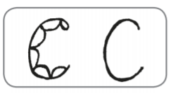
- Curl around the body

_____________________________________________________________________________

Step 2
- In RWI lessons, pupils should learn how to place their letters on the line appropriately. Pupils should use wide-lines paper or books with wide lines.
- It is important that the adult now models the letter formation on the line so that they can demonstrate and explain how the letter should be placed on the line correctly
Note: the size of the letters may vary from letter to letter.

For example:

- Curl around the body

- Start at her hair bobble on top of her head
- Draw a nice round face
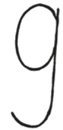
- Go back up to her bobble
- Down her very straight hair
- Draw a round curl to finish

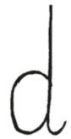
- Draw a big round bottom
- Up the tall neck
- Down the straight line to the feet
- Draw a curl for the feet.

- Mnemonics should continue to be used to help pupils visualize the letter.
______________________________________________________________________________

Step 3
- In RWI lessons, pupils should develop their letter formation by now focusing controlling the size of the letters and therefore additional lines and visual prompts are introduced e.g. sun, board, water. This is based on Phonics Handwriting Stage 1b.

‘Boat’ letters: a c e i m n o r s u v w x z

For example;

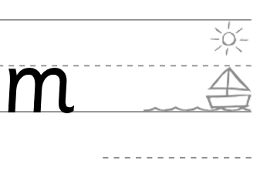

‘Water’ letters: g j p q y

For example;

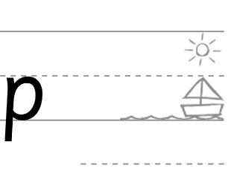

‘Sun’ letters: b d h k l t f

For example;

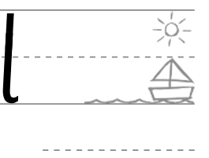

______________________________________________________________________________

Year 1
National Curriculum Expectations-
- To sit correctly at a table, feet flat on the floor, holding a pencil comfortably and correctly.
- To begin to form lower-case letters in the correct direction, starting and finishing in the right place
- To form capital letters
- To form digits 0-9
- To understand which letters belong to which handwriting ‘families’ (i.e. letters that are formed in similar ways) and to practise these
______________________________________________________________________________
Step 4a
- In RWI lessons, adults progress to modelling the letter shapes using the schools adopted cursive letter shapes with lead in and lead outs (individual letters), and when writing more than one letter, teachers model using the adopted joined cursive script.
Note: Pupils are not expected to join the letters at this point, however this should be modelled so pupils begin to experience joined cursive script.
- Pupils should initially focus on supporting pupils to understand the size of different letters with the addition of lead in and lead out. Pupils will continue to use the visual prompts of the boat, water and sun and practise individual letters.

‘Boat’ letters: a c e i m n o r s u v w x z

For example;

‘Water’ letters: g j p q y

For example;

‘Sun’ letters: b d h k l t f

For example;
___________________________________________________________________________
Step 4b
- In addition to RWI lessons, in Year 1, pupils have weekly handwriting lessons.
- In handwriting lessons, pupils will continue to develop their understanding of the different size of letters in relation to one another by practising them in letter groups; ‘around’, ‘down’, ‘curly’ and ‘zigzag.’
- Pupils practise the individual letter shape using the cursive principles including lead ins and lead outs in the order listed below.

‘Around’ letters: a d g c o q
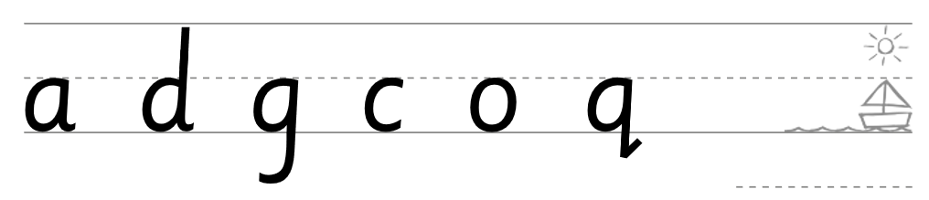
‘Down’ letters: l h k b t j m
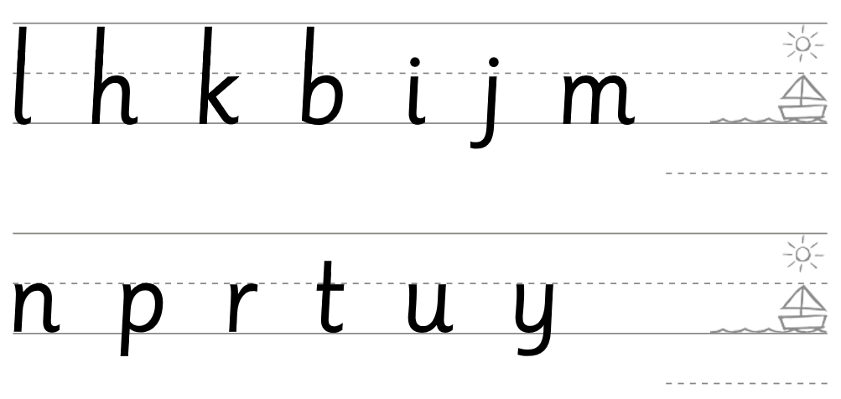

‘Curly’ letters: e s f
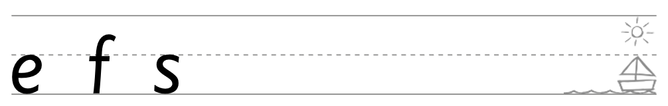

‘Zigzag’ letters with all other letters: v w z x

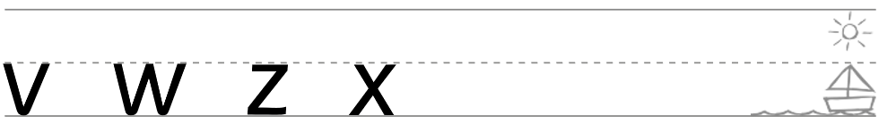

______________________________________________________________________________

Step 5
- In handwriting lessons, pupils are taught capital letters and the difference between capital letters and their matcher lower case letter.
- Links to the boat, water and sun letters should be made to support pupils visualizing the size of the letters.

For example;
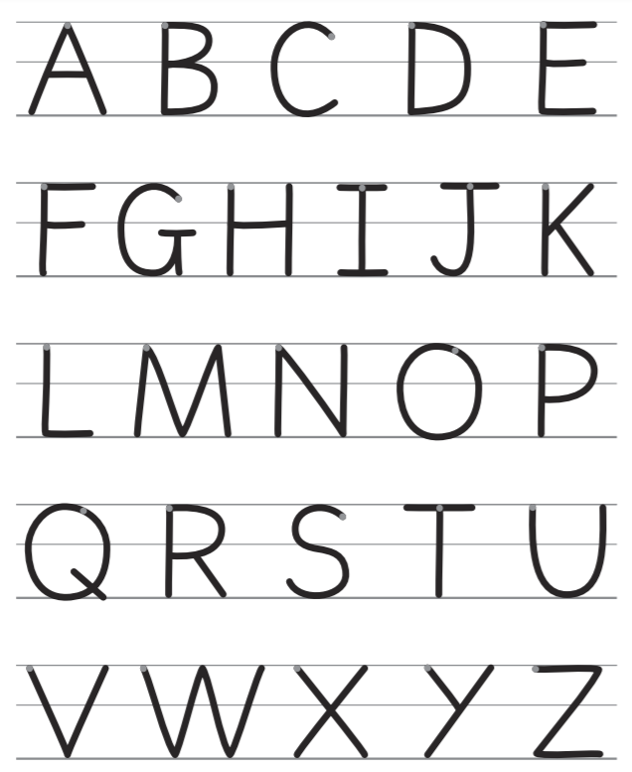

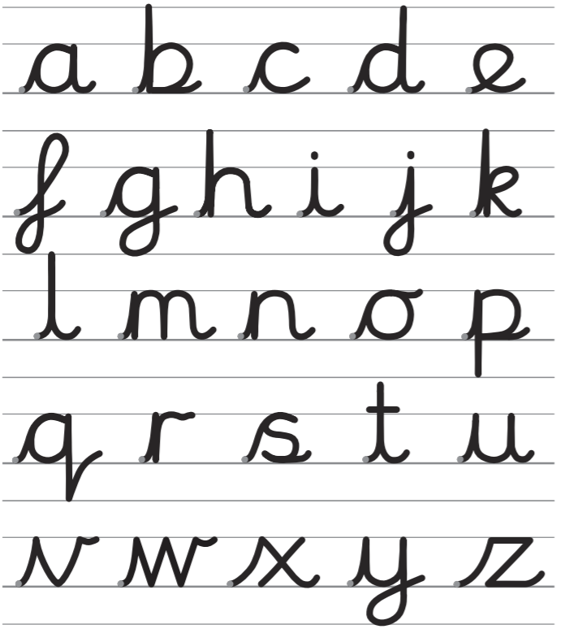

Note: Pupils in Year 1 may progress onto ‘Step 6’
__________________________________________________________________________
Year 2
National Curriculum Expectations-
- To be able to form individual letters correctly, so establishing good handwriting habits from the beginning.
- To revise and practise correct letter formation frequently.
- To write with a joined, cursive style as soon as they can form letters securely with the correct orientation.
_____________________________________________________________________________
- In RWI lessons, adults continue to model the letter shapes using the schools adopted cursive letter shapes with lead in and lead out (individual letters), and when writing more than one letter, teachers model using the adopted joined cursive script. Pupils are expected to begin to join the letters, following the introduction of the joins.
Note: This may have already begun in Year 1

Step 6a
- In Year 2, pupils continue to have weekly handwriting lessons.
- In handwriting lessons, pupils will be introduced/recap the two basic joins: the arm join (diagonal) and the washing line join (horizontal).

There are three variations to these two basic joins:

The arm join has three variations:

a. arm to boat joins “lead up”
(Use for joining: a c d e h I k l m n t u q s b g j y p to: e I j m n p r u v w x y z)

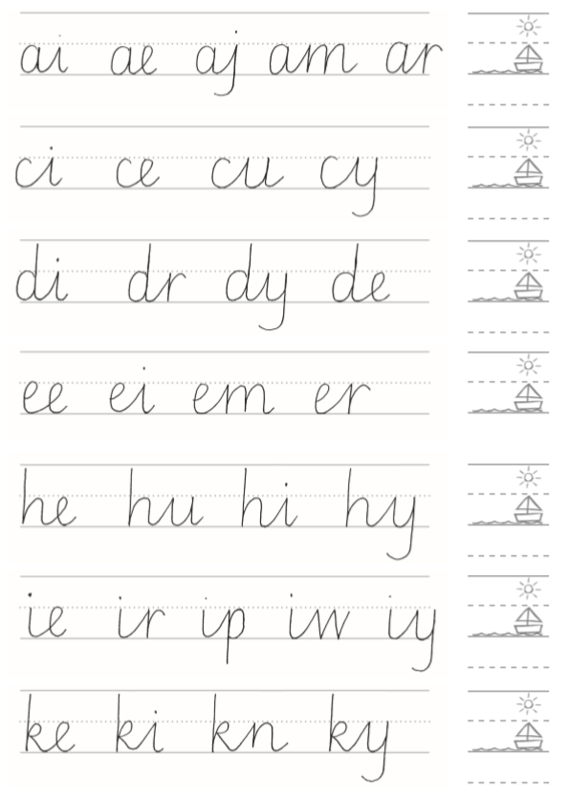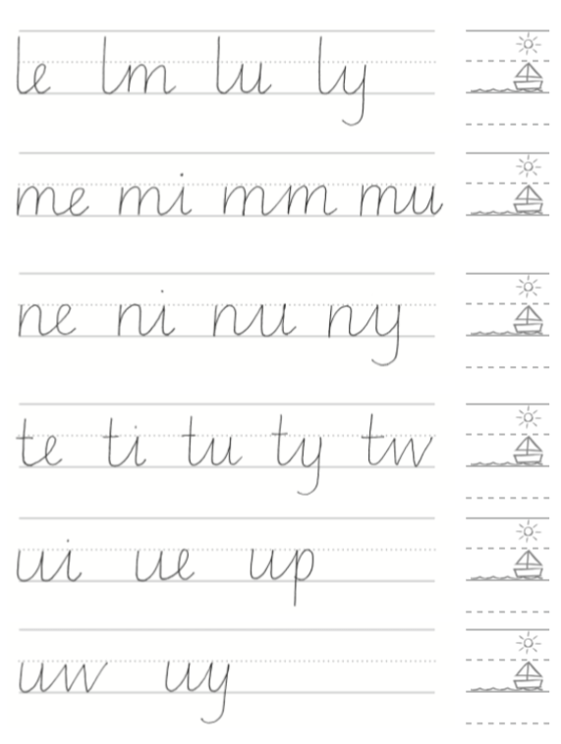

b. arm to sun “shoot up to the top”
(Use for joining: a e I d h k l m n t u c s b g j y p to: b h k l t)
Step 6b
Step 6c

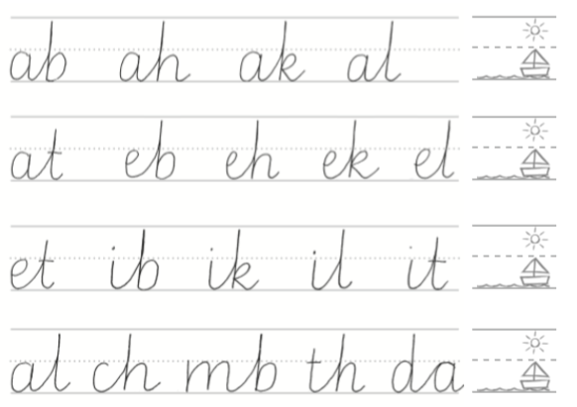

c. arm to boat “lead up and over”
(Use for joining: a c d e h I k l m n t u s b g j y p f to: a d g c o q)
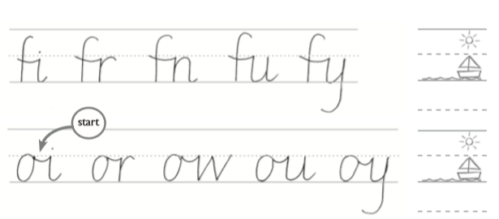
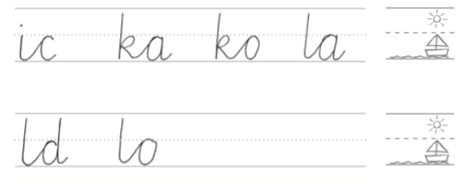
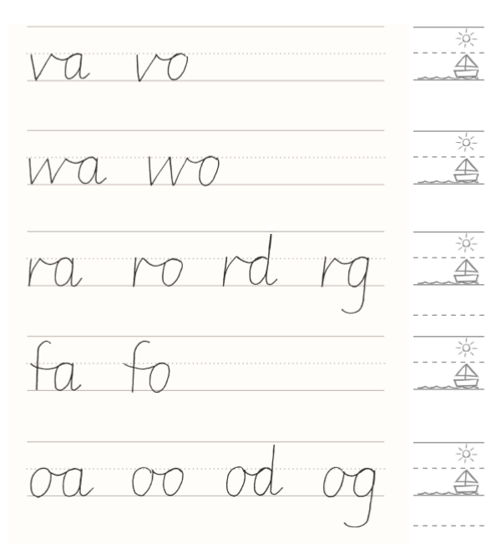

The washing line has three variations:
Step 6d

d. washing line to boat “Lead across”
(Use for joining v w r f o z to: I j m n p r u v w x y z e)

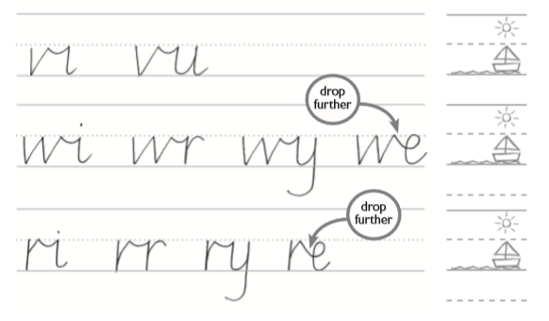

Step 6e

e. washing line to sun “Lead across and shoot up”
(Use for joining: v w r f o z to: b h k l t)

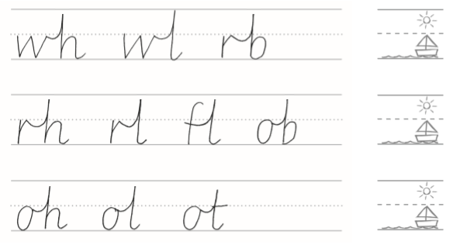

f. washing line to boat “Lead across and over”
(Use for joining v w r f o z to: a d g c o q)
Step 6f

______________________________________________________________________________

In further handwriting lessons, it is advised that handwriting and spelling are taught alongside one another to promote this being a transferable skill. All handwriting skills should be modelled during the writing of spelling words.
If adults identify pupils needing additional practise of a specific handwriting skills, teacher re-model, explain and teach as necessary.
Note: This might take the form of 1:1 practise, group or whole class practise to ensure pupils expectation of handwriting remains consistent.
When pupils achieve a neat, legible and joined cursive script with lead in and lead outs, pupils can be awarded their pencil license. (See handwriting policy, celebration of handwriting.)
______________________________________________________________________________

Key Stage Two

Year Three and Four
National Curriculum-
- To use the diagonal and horizontal strokes that are needed to join letters and understand which letters, when adjacent to one another, are best left unjoined
- To increase the legibility, consistency and quality of their handwriting

In Year 3 the majority of pupils will:
- continue to use joined cursive handwriting throughout their independent writing
- develop writing fluency, speed and stamina
- produce writing that sit appropriately on the line.

In Year 4 the majority of pupils will:
- use joined cursive script
- write ascenders and descenders in the correct place and on the lines.
- have automaticity (e.g. not having to think about formation)

Year Five and Six
National Curriculum-
- To write legibly, fluently and with increasing speed by:
  - choosing which shape of a letter to use when given choices and deciding whether or not to join specific letters
  - choosing the writing implement that is best suited for a task.

In Year 5 and 6 the majority of pupils will:
- use a consistent size and spacing
- write with a cursive, legible, accurate style
- have an awareness of the following three speeds of writing:
1. Speed one: slower, neat writing for letters and presentation.
2. Speed two: Fast and legible everyday writing that others can read.
(This is the style that is used most regularly).
3. Speed three: Very fast note writing - not very tidy but can be read by the writer.
- Pupils choose the writing implement that is best suited for the task
(e.g. a pencil for quick notes, a pen for letter.)

